Received 24 June 2022, accepted 21 July 2022, date of publication 25 July 2022, date of current version 29 July 2022.

*Digital Object Identifier 10.1109/ACCESS.2022.3193670*



Combating Fake News: Stakeholder Interventions and Potential Solutions

ANKUR GUPTA1, (Senior Member, IEEE), NEERAJ KUMAR2, (Senior Member, IEEE), PURNENDU PRABHAT1, RAJESH GUPTA3, (Student Member, IEEE),



SUDEEP TANWAR3, (Senior Member, IEEE), GULSHAN SHARMA4, PITSHOU N. BOKORO4, (Member, IEEE), AND RAVI SHARMA5



* Department of Computer Science and Engineering, Model Institute of Engineering and Technology, Kot Bhalwal, Jammu, Jammu and Kashmir 181122, India

2Department of Computer Science and Engineering, Thapar Institute of Engineering and Technology (Deemed to be University), Patiala, Punjab 147004, India 3Department of Computer Science and Engineering, Institute of Technology, Nirma University, Ahmedabad, Gujarat 382481, India

4Department of Electrical Engineering Technology, University of Johannesburg, Johannesburg 2006, South Africa

5Centre for Inter-Disciplinary Research and Innovation, University of Petroleum and Energy Studies, Dehradun 248001, India

Corresponding authors: Sudeep Tanwar (sudeep.tanwar@nirmauni.ac.in) and Gulshan Sharma (gulshans@uj.ac.za)

 **ABSTRACT** The fake news ‘‘infodemic’’, facilitated by social media and mobile message sharing platforms, has progressed from causing a nuisance to seriously impacting law and order through deliberate and large-scale manipulation of public sentiments. There are social, religious, political, and economic dimensions to the fake news phenomenon, providing enough motivation for interested parties to push biased opinions, claims, conspiracies and fraud to many naïve information consumers. The ease with which fake news can be created and propagated makes it extremely challenging to detect and mitigate. To combat the fake news, the researchers have utilized mechanisms which are largely based on Arti cial Intelligence (AI) algorithms and social network analysis. However, no viable solution has yet been deployed at a scale. This paper present a comprehensive survey on combating fake news and evaluates the challenges involved in its detection with the help of existing detection mechanisms and techniques to control its spread. The challenges associated with combating fake news have been addressed based on the various aspects such as psychological, economic, and technical. Furthermore, we consider the fake news combat spectrum to analyze the stakeholder interventions due to the spread of fake news. Finally, various technology-based solutions have been presented for combating fake news and the associated future challenges and opportunities.



 **INDEX TERMS** Fake News, misinformation, disinformation, infodemic, fake news detection.



**I. INTRODUCTION**

The global uncertainty due to the COVID-19 pandemic has manifested in a breeding ground for fake news resulting in widespread panic, stymieing the efforts of governments worldwide to disseminate credible information to its citizens. But, the fake news regarding taking wrong procedures to protect from COVID-19 has taken its place in this scenario resulting in promoting racial hatred and distrust. The term fake news is de ned as a fabricated information, which is well crafted with a purpose having sensation and emotional touch that mimics the original information. This gamut of global

The associate editor coordinating the review of this manuscript and approving it for publication was Tie Qiu .



fake news was referred to as the ‘COVID-19 infodemic’ by the world economic forum [1]. The Government of India recently informed the supreme court of India that fake news regarding COVID-19 had been a major impediment in ghting the pandemic [2].

The COVID-19 fake news mainly originated from sources that depend upon clickbait for revenue generation, politi-cally motivated sources, fake pro les on social media and accentuated by a large number of shares/forwards on mobile messaging applications [3], [4]. This fake news is shared in the form of text, voice, image, and videos and has great impact (negative or positive) on social media users. Most of the sources claimed to be from renowned bodies like the government and international organizations engaged in

|  |  |  |  |
| --- | --- | --- | --- |
| 78268 | This work is licensed under a Creative Commons Attribution 4.0 License. For more information, see https://creativecommons.org/licenses/by/4.0/ | VOLUME 10, 2022 |  |
|  |  |

A. Gupta *et al.*: Combating Fake News: Stakeholder Interventions and Potential Solutions

responding to the pandemic [5]. It is circulated widely over social media (like Facebook, Twitter, Instagram), mobile messaging apps (like WhatsApp), video hosting services (like YouTube, Vimeo) and various websites. Millions of bots operating through fake pro les helped make the shared content go viral until it was perceived as true by information consumers and forwarded further to their contacts.

While the pandemic has exacerbated the fake news menace, it was already a real problem impacting all aspects of public life from presidential elections to politics, issues of law and order to economic fraud [6]. There has been an increased research focus to understand the nature and spread of fake news to build solutions to detect and control it [7] [9]. In [9], the authors presented a survey on fake news and rumour detection techniques. They have adopted different approaches to handle the diverse datasets required for the fake news detection based on the various features to present the future opportunities and challenges associated with it. Later, Sharma *et al.* [8] also studied the need of concrete datasets to avail the fake news mitigation and detection with the technical challenges associated with it. Then, Zhou *et al.* [7] presented a comprehensive survey on fundamental theories and detection methods for mitigating the fake news. They have highlighted the fundamental theories to reinforce the interdisciplinary research on fake news in various eld. However, most of the research works involve limited datasets with no viable solution for fake news detection with the trust issues against the user’s privacy. Therefore, a viable solution is highly desirable to control and mitigate the spread of fake news. This paper articulates the characteristics of fake news, the challenges involved in building fool-proof solutions to detect and mitigate it, and reviews existing work done in the domain and their shortcomings. Several possible interventions are examined from the perspectives of various stakeholders and early ideas on a viable framework to check the spread of fake news are presented. Further, we have compared the existing research works on fake news detection with the proposed survey to spotlight the bene ts associated with it.

**A. RESEARCH CONTRIBUTIONS**

This paper contributes the following to the knowledge in the domain of fake newsV

We present a detailed discussion on characteristics of fake news, its origins, and conceptual model to visualize the motive, manifestation, spreading mecha-nisms, platforms, and in uencing mechanisms for fake news.

We present an insights on challenges to combat fake news based on their psychological, economic, and technical aspects. Also, discuss the fake news combat Spectrum, the initiative taken by different stakehold-ers/actors and their desirability.

We presented the categorization of technology-mediated solutions for combating fake news and suggested a viable solution for checking the fake news spread.

VOLUME 10, 2022

**B. SURVEY ORGANIZATION**

The rest of the paper is organized as follows: Section 2 describes the methodology that was followed for this review. Section 3 presents the characteristics of fake news including a model for its representation. Section 4 identi es the chal-lenges in detecting fake news which have prevented a viable solution from being formulated and deployed so far, while Section 5 outlines a fake news combat spectrum with possible interventions at the level of different stakeholders the users, the platforms and the governments. Section 6 describes recent technological approaches and advancements to detect fake news and mitigate its spread, along with their shortcomings. A potential viable solution for checking the spread of fake news is described in Section 7. Finally, Section 8 concludes the paper.

**II. SCOPE OF THE SURVEY**

The existing surveys discuss the combating and detecting the fake news to bifurcate the true and false information to mitigate the propagation of fake news. Nevertheless, most of the authors did not highlight the need to provide security and privacy to the user’s con dential information. For example, Zubair *et al.* [10] explored about combating the fake news according to the islamic ethical tradition. The review has analyzed the Islamic guidelines to detect fake news (misinformation) and machine learning generated fakes. Then, the authors in [11] presented a survey on evaluating the detection of fake news along with the techniques on social networking sites. However, they have ignored the content privacy while improving its quality further affecting the per-formance of the fake news detection. Therefore, to strengthen the performance for fake news detection, Hakak *et al.* [12] also discussed a survey on mitigating the propagation of fake news on social media. They reviewed the several fake news detection approaches associated with the various research opportunities and future challenges. Furthermore, the authors of [13], [14] explored a comprehensive survey on combating fake news during the COVID-19 pandemic. Although, they have not highlighted the user’s privacy and detection of fake news with high modularity. Later, to overcome the trust issues of [13], [14], Ansar *et al.* [15] presented an exhaustive survey to perform the detection of fake news from the data science outlook. They have mitigated the privacy issues related to the information, but social bots and clickbaits detection is not considered to that much extent. Alternatively, the authors of [16] also focused on combating and controlling the spread of fake news on the social media platforms, but they also did not highlight any mechanism for social bots detection. They have analyzed numerous methods such as Natural Language Processing and hybrid model for fake news detection. Furthermore, Shahid *et al.* [17] studied the dissemination of fake news by incorporating the AI-based system to present the research challenges and opportunities associated with it. Later, the authors of [18] presented a comprehensive survey on detecting fake news spreaders

78269

A. Gupta *et al.*: Combating Fake News: Stakeholder Interventions and Potential Solutions

**FIGURE 1.** Prisma diagram of the proposed study.

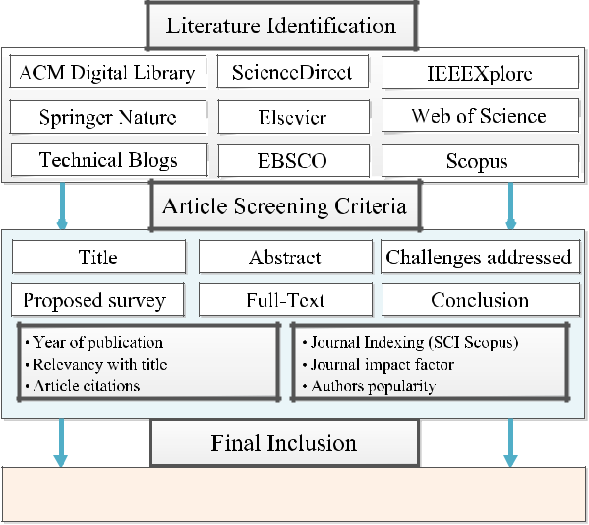

to deal with the security and privacy issues in real time identi cation of cyber bots and malicious user based on the various features.

Further, to deal with complexity issues of [18], Varlamis *et al.* [19] presented a survey on combating and mitigating the propagation of fake news based on the Graph Convolution Networks. Later, the authors in [20] studied the impact of detecting misinformation in data story to reinforce the text credibility. Nevertheless, most of the researchers with their solutions have not involved the fake news detection based on the various technical, economic, and psychological aspects. Moreover, user’s privacy is completely ignored while combating fake news. Therefore, in this paper, we conducted an exhaustive survey on combating fake news by categorizing the various technology-based solutions with the different stakeholders intervention. Table 1 shows the comparative analysis of various state-of-the-art combating fake news surveys with the proposed survey.

**III. METHODOLOGY**

In this section, the methodology employed for the present research is outlined.

**A. RESEARCH QUESTIONS**

The existing literature available on fake news was examined. Based upon the detailed literature review gaps in the domain, limitations of existing work and future work identi ed by researchers in existing works were collated. Table 2 summarizes the identi ed research questions and motivation for research.

**B. DATA SOURCES**

We have performed an extensive literature search on standard peer-reviewed journal databases including IEEE Xplore, ACM Digital Library, ScienceDirect, Elsevier, Springer,

78270

EBSCO, Scopus, Web of Science, and Google Scholar to get insights into the detection of fake news of various research works. Relevant papers are shortlisted for further ltering. Further, web references are also examined through Google searches. A total of 228 research articles, white papers and web references are collated in this phase.

**C. SEARCH CRITERIA**

Some of the keywords for search were: fake news, fake news survey, disinformation, misinformation, malinforma-tion, combating fake news, fake news detection challenges, history of fake news, technical challenges in detecting fake news, government policy for fake news minimiza-tion, platform-level intervention in Combating fake news, Facebook fake news, Laws against fake news, WhatsApp fake news, twitter fake news, Google fake news, AI-based solutions for fake news, AI-generated fake images, Con-trolling spread of fake news etc. All these searchers are performed using logical seperation words such as AND and OR. For example, fake news AND misinformation, fake news AND challenges, WhatsApp OR Twitter fake news, and many more combinations. Figure 2 shows the graphical view of the search strings used in the paper.

**D. CRITERIA OF INCLUSION AND EXCLUSION**

A total of 65 research articles were excluded on the basis of low relevance to the research questions framed. Research articles were further ltered based onV

Relevance of work done and contribution Quality of work done and contribution

Quality of the journal/conference and publisher

Number of citations for the paper and also consider low or no citations papers based on the relevancy with the

topic.

This led to further exclusion of 71 articles. We nally selected 92 research articles and 56 web references which exhibited high relevance to the research questions. The present work attempts to provide a holistic picture of the fake news problem from a theoretical, social and technical perspective. The issue is examined from the perspective of different actors/stakeholders in the ecosystem to answer questions on what is feasible in the global ght against this menace. FIGURE 1 shows the prisma diagram to present the criteria for complete screening of the proposed study.

**IV. FAKE NEWS: ORIGIN AND CHARACTERISTICS**

The Cambridge Dictionary de nes news as ‘‘information or reports about recent events’’ [23]. News is commonly used to make informed decisions, which affects stock markets, national security, our personal choices, and even our interaction with people around us, shaping our perception of the world we live in [24]. However, the formal de nition of the term fake news is still open to debate. Hence, the house of commons in the UK has decided to use two terms: disinformation and misinformation [25]. Misinformation is a false or sometimes out of the context information

VOLUME 10, 2022

A. Gupta *et al.*: Combating Fake News: Stakeholder Interventions and Potential Solutions

**TABLE 1.** Comparative analysis of various state-of-the-art combating fake news surveys with the proposed survey.

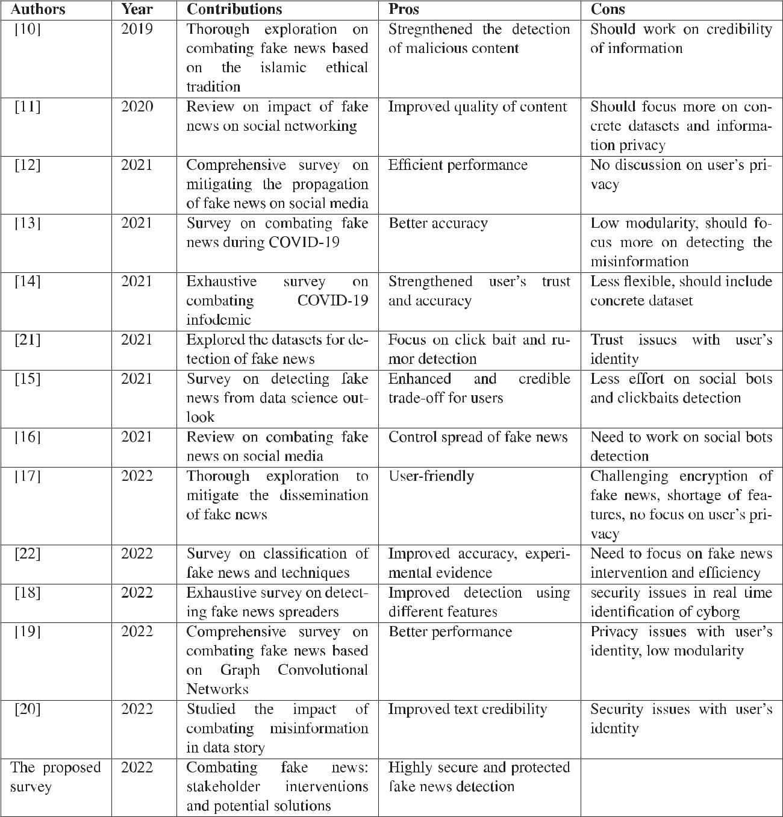

presented via facts without the intent to deceive. Whereas, disinformation is a kind of misinformation with the intention to mislead the audience [26]. The Council of Europe uses the term information disorder, which includes misinformation, disinformation, and malinformation [27]. Malinformation is when genuine information is shared to cause harm.

Incidents of fake news have been documented in the West as early as 63 BC when Roman Emperor spread disinformation to earn a victory [28]. An interactive timeline

VOLUME 10, 2022

for fake news events is present at [29]. Before the printing press was invented, written records were kept in monasteries and libraries, which were veri ed correctly. The monasteries or libraries were state-funded and any manipulation of information was not possible without the nexus of the ruling government [30]. So, disinformation spread was contained unless it was state-sponsored. In any case, many different versions of historical accounts existed worldwide. Groups with the greater might ensured that their version of history

78271

A. Gupta *et al.*: Combating Fake News: Stakeholder Interventions and Potential Solutions

**TABLE 2.** Possible research questions to carryout the proposed survey.

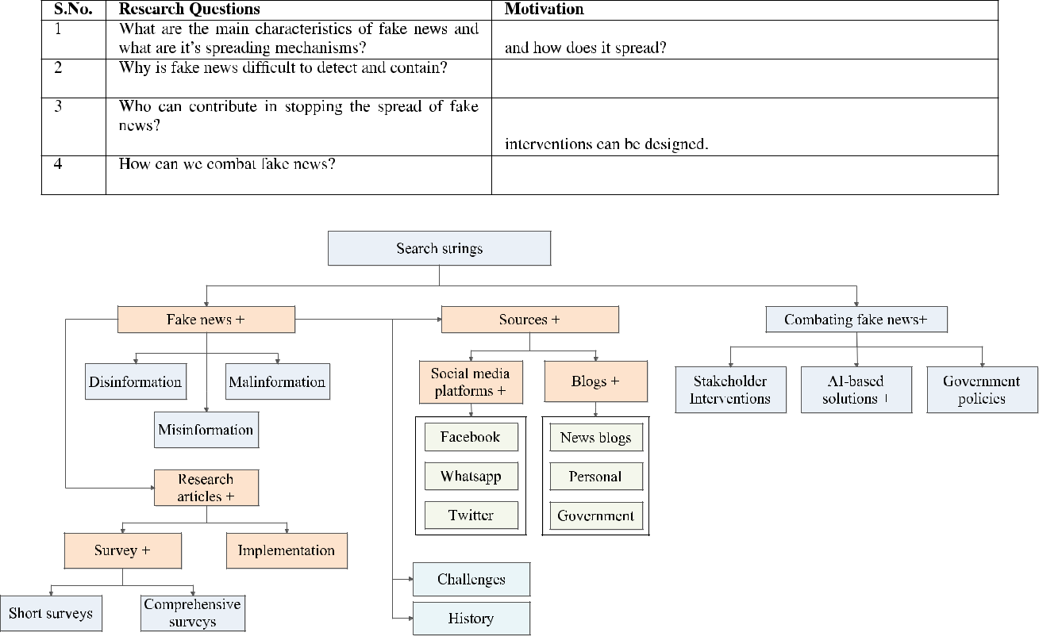

**FIGURE 2.** Used search strings.

endured and was accepted as the true account by the people. Once the press was invented in 1439, many unveri ed works were created and circulated, which gave more space to disinformation [31]. It wasn’t until 1610 when Galileo went on trial, that the demand for veri ed news increased Misinformation led to the French Revolution in the 18th century and had false claims and publications from both the revolutionaries and the government [32]

Yellow journalism, a form of eye-catching journalism sans substantial legitimate and well-researched news, provoked the USA into the Spanish American War [33]. The 20th century had industry scale printing presses which accelerated disinformation. The century saw two world wars, with organized disinformation and propaganda fanning racial prej-udices and extreme nationalism leading to the Holocaust [34]. Paddock in [35] gives a very detailed account of the use of propaganda in World War I. The BBC History Magazine Podcast [36] discusses the fake news in World War II. Hitler had a special department for propaganda called the *Ministry of Propaganda* [37].

The advent of social media has placed the power of spreading disinformation and misinformation in the hands of potentially all individuals [38]. No wonder fake news incidents and their impact has grown manifold. It is estimated that in the 2016 US presidential election, fake

news was shared 30 million times on Facebook [39]. The hoax regarding worm meat used in McDonald’s burgers is another prime example of using fake news to damage corporate reputations [40], while false claims over Brexit [41] led to fractured electoral mandates, political upheaval and economic losses. In India, fake news created law and order challenges through incitement and sentiment manipula-tion [42]. Deepfake [43] leverages deep learning techniques to synthesize multimedia by replacing a person’s existing image or video with someone else, having a high potential to deceive. LyrebirdAI [44] learns human voices quickly and can generate a person’s voice for a given text. Technological advancements like Deepfake and LyrebirdAI support disin-formation, while the presence of social media bots, unveri ed accounts, trolls and dependency on internet search engines for information have magni ed misinformation [45]. Unveri ed online advertising over social media and websites promote disinformation while end-to-end encrypted mobile message sharing applications make it nearly impossible to track and curb misinformation [46].

To understand the characteristics of fake news, we exam-ined different models articulating the characteristics of fake news. A summary of these models is provided in Table 3. The First Draft News Model by Claire Wardle described in [47] discusses different types of fake news, motivations/reasons

78272 VOLUME 10, 2022

A. Gupta *et al.*: Combating Fake News: Stakeholder Interventions and Potential Solutions

**TABLE 3.** Summary of conceptual models of fake news.

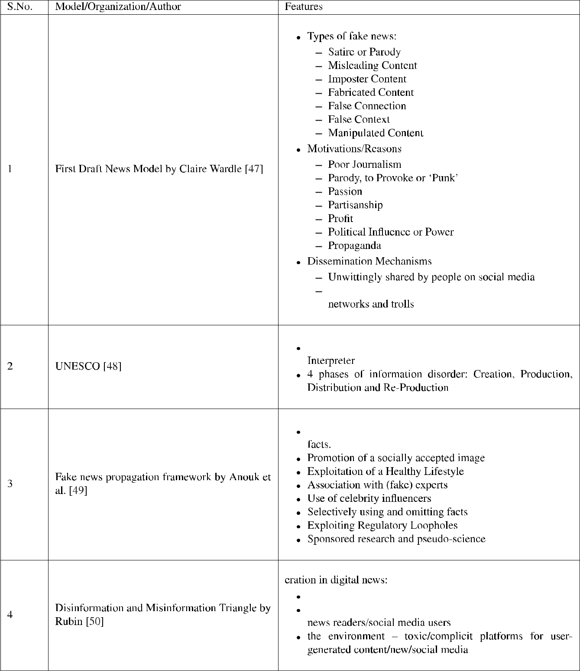

for fake news and the dissemination mechanisms. The UNESCO model discusses the three elements of information disorder, namely Agent, Message and Interpreter and their

VOLUME 10, 2022

4 phases, namely creation, production, distribution, and re-production [48]. The fake news propagation framework by Anouk *et al.* discuss the false association, promotion, and

78273

A. Gupta *et al.*: Combating Fake News: Stakeholder Interventions and Potential Solutions

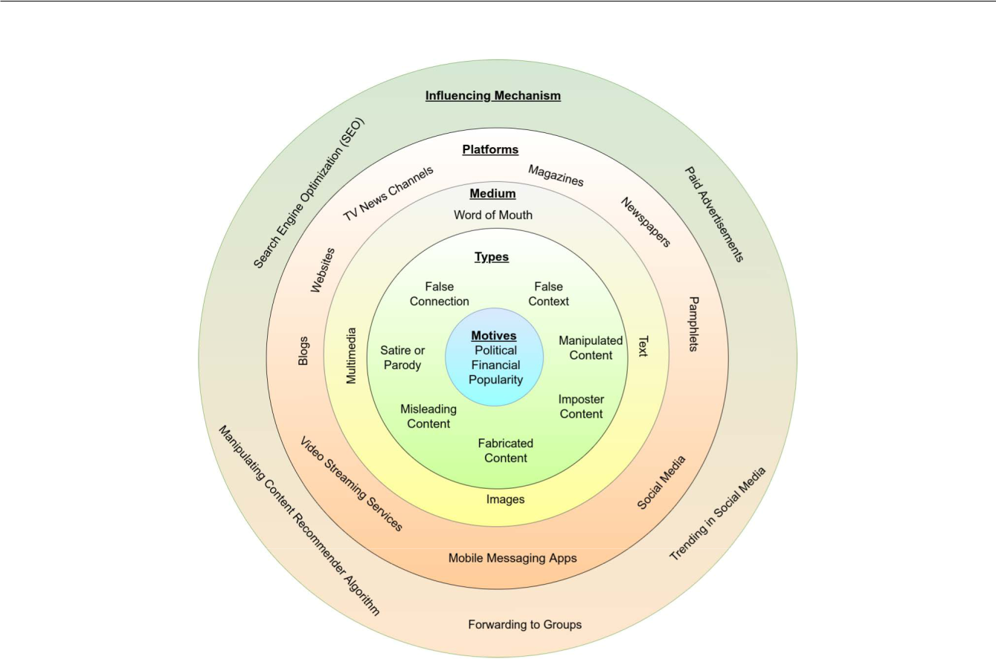

**FIGURE 3.** Fake news characteristics classification model.

the use of celebrity in uencers [49]. The disinformation and misinformation triangle by Rubin examines three determi-nants for the proliferation of fake news in digital news: the pathogen (fake news), the host (people who accelerate the spread of fake news) and the environment (platforms over which the fake news spreads) [50]. It can be seen that these models focus on speci c aspects of fake news, for instance, the elements involved or the spreading/in uencing mechanisms. We present a uni ed representation of fake news characteristics (Figure 3), providing a comprehensive picture of why fake news is created, how it spreads, where it spreads and how its impact is ampli ed. We observe that fake news is a centrifugal phenomenon, starting with the motive at the centre, manifesting in different types, spreading through various mediums via different platforms and getting magni ed through one or more in uencing mechanisms.

The main elements of the fake news characteristics classi cation model (also shown in Figure 3) are discussed in detail below:

*Motive*: The main characteristic of fake news is the motive, whether political, economic, or religious, ema-nating from nations, commercial organizations, com-munities, fringe groups, and individuals [48]. Authors in [39] nd that motives for fake news can be either nancial or political bene t. The video ‘‘Why is Fake News Created?’’ [51] by Madison College Library

78274

discusses that there are three main drivers of fake news: satire, desire to in uence public opinion and generation of ad revenue. Motivations or reasons for fake news as discussed by Claire Wardle in [47] are poor journalism, parody, passion, partisanship, pro t, political in uence or power, and propaganda. We see that all the above-discussed motives belong to one of the following categories, such as political, nancial, and popularity.

*Types*: A news item consists of an attractor, content and sources [52]. Attractors are the headlines, visuals, and captions that attract viewers to read the content. The more unbelievable, shocking or controversial the attractor, the more is the tendency of the receivers to examine that item [53]. Content is the actual descriptive part of the news item that is being reported, which may spark curiosity in a reader to check for the sources. According to a survey, around 80% of the readers don’t read beyond the attractor [54]. Carefully interspersed elements of false information in a news item can also change its overall perception while attributed to credible sources. Fake news can be broadly categorized into the following types [55]:

*False Connection*: when attractor doesn’t support the content

*False Context*: when genuine content is shared with false context

VOLUME 10, 2022

A. Gupta *et al.*: Combating Fake News: Stakeholder Interventions and Potential Solutions

*Manipulated Content*: when genuine content is manipulated

*Satire or Parody*: to fool, but not to harm

*Misleading Content*: to frame an issue or individual

*Imposter Content*: when genuine sources are impersonated

*Fabricated Content*: totally new and false content intended to deceive and harm

*Medium*: The third de ning characteristic of fake news is the medium; word of mouth, text, images and multimedia content. Its circulation in the form of audio-video is the most dif cult to detect and are more prone to be perceived as real [56]. Numerous videos shot in different countries have been propagated as accounts of local events to ferment violence exist. When used out of context, news in the form of pictures results in public anger and outbursts. Photoshopped and morphed pictures cause equal harm. These morphed pictures trend on social media through sharing by bots and human routers, garnering likes and comments, in turn making it available to a wider audience [57].

*Platforms*: Fake news has been disseminated through multiple platforms like the print media (newspapers, pamphlets, magazines), television news channels, web-sites, blogs, social media like Facebook, Instagram and Twitter, video streaming services like YouTube and Vimeo, and mobile messaging apps like WhatsApp and Messenger [47]. Social media and mobile messaging applications account for over 90% of the fake news in the world owing to their large user base and ease of sharing [58]. WhatsApp is a major contributor to misinformation in India [42].

*In uencing Mechanism*: To create impact and in uence public opinion, fake news mongers aim to get content trending on social media by increasing the number of views, likes and shares and using hashtags. In fact, several studies have shown that there are often groups of users that heavily share fake news, particularly just after its publication [59], [60]. They optimize the content of their web/blog article for a higher ranking in internet search engines using repetitive and super uous words, which are most searched on the internet. They promote their content by paid advertisements on social media and websites to reach a wider targeted audience. Unfortunately, there is no substantial vigilance mechanism for misleading advertisements over the internet. Most social media and video streaming services provide a recommendation based on user preferences which can be manipulated to be in the recommended list of the target audience. A very subtle method that is not recognizable in the public domain is forwarding messages to groups in mobile messaging apps, which are impossible to monitor.

1. **CHALLENGES IN COMBATING FAKE NEWS**

This section describes various challenges to combat fake news.

VOLUME 10, 2022

**A. THE PSYCHOLOGY OF FAKE NEWS**

Fake news exists because it is consumed and even propagated by the public, the major stakeholder. Even educated people display remarkable naivete when it comes to discerning and sharing fake news. People relate to stories more than actual facts and are intrigued by conspiracy theories and viewpoints that challenge popular belief. Research shows that people are more likely to consider a piece of information to be true if it ts their belief systems which become xed over time [61]. Humans exhibit a con rmation bias, due to which they use the information to con rm and strengthen their existing beliefs, biases and ideologies. Individuals also tend to overestimate their knowledge levels and inaccurately judge fake news as true [62]. Another factor is the lack of time and effort that people are willing to invest in determining the veracity of a news item. Social media creates for individuals what is referred to as a ‘‘ lter bubble’’ [63], their unique universe of information online. This lter bubble shows users targeted search results, news feeds, and content [64], eliminating diverse sources hindering their critical thinking and ability to discern. The speed at which content is delivered, consumed and shared also promotes fake news as intuitive and emotional information processing promotes belief in false content [65]. Finally, people, primarily teenagers, tend to reject journalistic objectivity credibility and consume most of the news on social media where being opinionated, controversial and getting involved in partisan discussions is normal [66]. Thus, human psychology in processing information and behavior on social media is the biggest challenge in checking fake news spread. This has resulted in researchers exploring increasingly technology-based solutions to check the spread of fake news.

**B. THE ECONOMICS OF FAKE NEWS**

There is a strong economic motivation for spreading mis-information and disinformation. Political mileage, nancial gains and aspiring for individual popularity incentivize the spread of disinformation. Nir and Jeffery [67] analyzed the economic value of disinformation. If the Monetory

1. bene t combined with the Psychological (P) bene t from the creation and management of fake news exceeds the direct Investment Cost (IC) combined with the Opportunity Cost (OC), Psychological Cost (PC), and Expected Penalty Effect (EPE); fraudsters will engage in disinformation.

|  |  |
| --- | --- |
| *M* C*P*>*IC*C*OC*C*PC*C*EPE* | (1) |

EPE factors the monetary cost of conviction, i.e. the probabil-ity of arrest and conviction. The primary mode of business for most digital companies is online advertisements. This has led to platform capitalism, wherein a highly engaged user-based is constantly bombarded with targeted advertisements based on deep analysis of user data, preferences and online behavior [68]. Therefore, online social network platforms have very little incentive to actively weed out fake news and advertisements as a highly engaged user base generates greater revenues. With the economic and political in uence,

78275

A. Gupta *et al.*: Combating Fake News: Stakeholder Interventions and Potential Solutions

these organizations have earned, the EPE (Eq. 1) for these is apparently less. It is entirely feasible for a platform such as Facebook to build AI-based solutions for detecting and tracking fake news, fake pro les, bots and groups which promote fake news. However, the lack of incentive, including a possible backlash by users for tracking their shared content, has prevented social media platforms from actively addressing the issue of fake news. Current interventions, including removing reported content and relying on human managers to ag fake news, are not effective, transparent and at best half-hearted. Correct information, however, does not necessarily balance or overcome fake information to achieve a natural equilibrium which makes the damage done due to popular fake news partially irreversible [69].

**C. TECHNICAL CHALLENGES**

Due to the advances in technology such as AI, deep learning, computer vision and related domains such as big data and cloud computing, it is feasible to expect a technology-based solution to counter fake news [70]. However, the complexity and diversity in how fake news is constructed, propagated and consumed make this view an oversimpli cation [71]. Therefore, technical solutions addressing speci c aspects such as detection, agging and fact-checking of fake news have been proposed in the literature. A truly universal technical solution, however remains a mirage for now. Zhou and Zafarani in [7] discuss that fake news does not yet have a universally accepted de nition. Thota *et al.* in [72] also state that de ning fake news is a problem in itself. Thus, the lack of a clear, concise de nition of what constitutes fake news prevents its accurate classi cation using existing AI mechanisms.

Zhang and Ghorbani in [70] conclude that the limited accessibility of high-quality labeled datasets is another major challenge for online fake news detection. Cultural diversity is a major reason for this, as what is construed as satire in one region of the world may be considered offensive in another and fake news in another. Wang in [73] attributes the lack of manually labelled datasets as a bottleneck for building advanced solutions for detecting fake news, while Parikh and Atrey [74] say that there are no multi-modal datasets available that cover all fake news types. This prevents corresponding AI models from being built, trained and deployed at scale. Monti *et al.* [75] discuss that the interpretation of fake news is required context and common sense, which natural language processing is still missing. Even human beings are not ef cient in detecting fake news [75], [76].

Sharma *et al.* in [8] discuss generalisation challenges with linguistic methods, accuracy concerns with deep learning methods and static nature of classi cation models based on user feedback. They raise data quality concerns and variations in methods used to collect data. They also state maintenance concerns for knowledge bases for fake news. Zhou *et al.* in [77] discuss the inef ciency of knowledge graphs for fake news detection as they are incomplete, do not contain knowledge of recent events and their inability to

78276

detect intentionally fake news. Shu *et al.* in [78] discuss the problems with the use of social media data for detecting fake news. Combating fake news poses serious technical challenges, which is why a viable solution is not yet deployed at scale. Based on the analysis of the existing literature in the eld and our own experience, we observe that the technical challenges in Combating fake news can be grouped into four heads (Figure 4):

The de nition of fake news itself has been de ned differently by different organizations and researchers. It is also popularly known as false news, disinfor-mation, misinformation or rumor. These terms are used interchangeably; however, they convey different meanings. False news originates from news sources and is untrue. Disinformation and misinformation are untrue information and may or may not originate from a news source. Rumors are unveri ed information that originated from unknown sources [7]. A critical analysis of multiple de nitions of fake news ranging from those describing it as false news to a purely online phenomenon is available in [79]. Problem statements for detection and Combating fake news have been de ned differently for different disciplines [80]. Variations in problem de nition and characterization have made it dif cult to formalize, leading to multiple research directions. This has led to diverse solutions, dif cult to consolidate into one integrated deployable solution.

*Language Diversity*: There are around 6,500 different languages in the world and the datasets are available mainly in English, Chinese, and other widely used languages while fake news can be propagated in almost all known languages [81]. Thus, a single solution to address fake news propagation in multiple languages is infeasible and requires customized solutions to be built and deployed.

*Datasets*: The ability to leverage AI in detecting fake news is limited to the availability of data for training the AI models [70]. Further, the data must be labelled, i.e. already categorized as true or fake; substantial examples must be present for each category. Two major issues with the present-day datasets on fake news areV

*Quantity*: Few datasets are available and that too is con ned to particular cases like the Syrian War, Brexit, or the 2016 US elections [73]. Datasets from a speci c timeframe and subject are not well suited for all time frames and subjects [74]. The datasets are available from open-access platforms like Twitter and other microblogging sites, while most social media platforms don’t allow user information extraction, given the privacy terms.

*Quality*: The creation of datasets depends mostly upon human classi ers, which introduces bias during data labelling [8]. Crowd sourcing the dataset is inauthentic as it depends upon the widely spread beliefs in the community [78].

VOLUME 10, 2022

A. Gupta *et al.*: Combating Fake News: Stakeholder Interventions and Potential Solutions

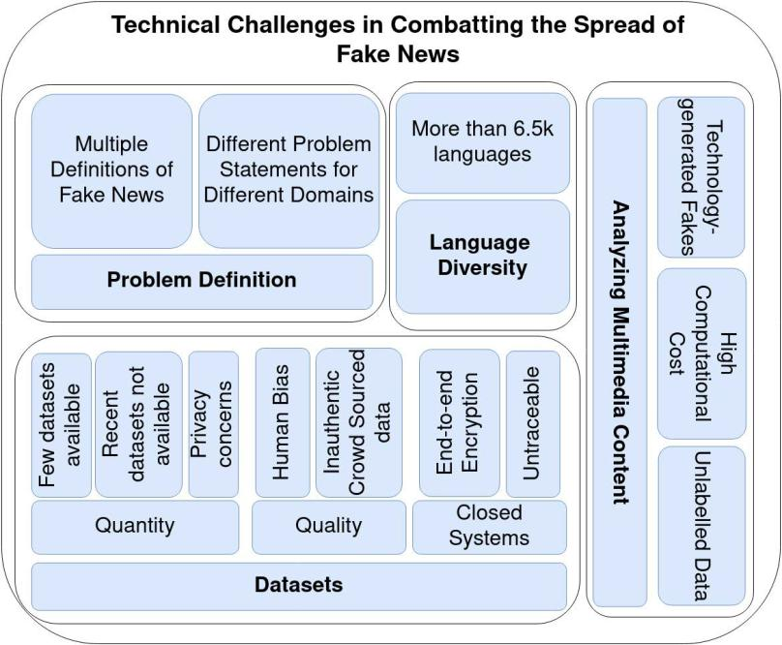

**FIGURE 4.** Summary of technical challenges in combating fake news.

*Closed Systems*: Applications like WhatsApp, Signal Telegram and Messenger are closed systems with end-to-end encryption. So, only the sender and receiver can view the message. This excludes the possibility to develop an automated method for detecting or tracking fake news. This is the most signi cant technical challenge as mobile message sharing applications have emerged as the largest propagators of fake news and misinformation [82]. While law enforcement agencies can still track social media pro les, they cannot track any message trails across mobile message sharing applications.

*Analyzing Multimedia Content*: Multimedia content used to spread fake news is dif cult to detect due to two signi cant reasons: Unavailability of labelled datasets that can be used to train models predicting the veracity of multimedia content and extremely high computation cost associated with the analysis of potentially billions of video and audio streams [83]. While techniques for determining whether multimedia content is doctored exist, newer AI technologies like Lyrebird AI [44], an AI-based voice cloning system and Deep Fake [43], a deep-learning-based image and video faking system; make detecting the authenticity of multimedia content challenging. Recent experiments by Groh *et al.* [84] suggest that human intuition is reliable for detecting manipulated multimedia content.

**VI. FAKE NEWS COMBAT SPECTRUM**

Figueira and Oliveira in [85] divide the ways of ghting fake news into two major categories (i) human interventions

VOLUME 10, 2022

and (ii) using algorithms. David Lazer *et al.* in [86] discuss two major interventions for Combating fake news

1. empowering individuals and (ii) platform-based detection and intervention (using algorithms and bots). Poynter in [87] has given a detailed account of recent laws and regulations made by governments around the globe for ghting fake news. Different stakeholders/actors who can work to combat fake news areV

*Users*: who consume fake news and can stop its spread by veracity assessment and deciding not to share fake news

*Platforms*: where fake news is spread, like Twitter, Face-book, WhatsApp, and other messaging and social media platforms. They can check fake accounts, information shared and apply application level ltering to counter the spread of fake news.

*Government/Society*: which can enforce laws and regu-lations, run awareness campaigns, etc.

Based on a survey of existing literature in combating the spread of fake news, we present a fake news combat spectrum in Figure 5 covering initiatives, interventions and solutions encompassing all signi cant stakeholders/actors; the users, the technology platforms and the governments. In terms of desirability, the interventions are classi ed from green to red, where green indicates that the users are empowered to accurately determine the accuracy of fake news in an utterly privacy-preserving manner, yellow indicates platform level intervention where privacy may be compromised. Red indicates government-level interventions which may lead to criminalization, prosecution and suppression of free speech.

78277

A. Gupta *et al.*: Combating Fake News: Stakeholder Interventions and Potential Solutions

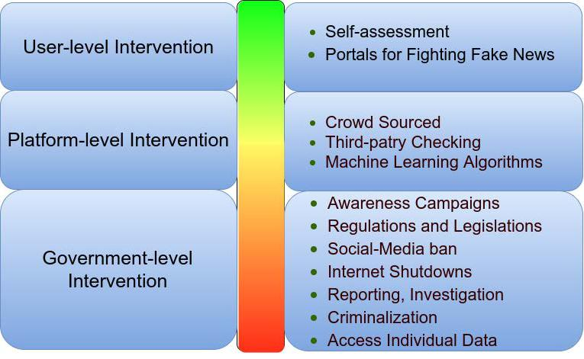

**FIGURE 5.** The fake news combat spectrum & desirability (green to red) of potential interventions at stakeholder-level.

The detailed discussion of the potential interventions at the level of the different actors/stakeholders is provided as follows.

**A. USER-LEVEL INTERVENTION**

The users in today’s information ecosystem can be producers, consumers and distributors of fake news. Through shared responsibility, users can perform self-veri cation of content they receive by cross-checking against credible sources or through fact-checking portals. User discretion in forwarding unveri ed content can also avoid the exponential spread of fake news.

1) SELF-ASSESSMENT

Newmark J-School’s fake news detection checklist [88] suggests users to ask the following questions before believing any news itemV

Who communicated the information? How they know about the information?

How they considered to be an authoritative source of information?

Is the source biased?

Are trusted websites posted the news?

What facts the information is being missing out?

Is this for the purpose of story making or popularity?

1. PORTALS FOR FIGHTING FAKE NEWS

The Reporters’ Lab manages a database for the organizations that checks the facts behind the informations posted [89]. Their system tracks or keep an eye on >100 organizations worldwide.

When skeptical about the veracity of a news article, users can visit one of these portals to verify the news, based upon the location and type of the news. International Fact-Checking Network (IFCN), a unit of Poynter Institute, is a global network of fact-checkers that promotes best

78278

practices and ethics while providing funds and fellowships to fact-checkers [90]. A veri ed list of fact-checking portals are also available at [91]. Some prominent ones areV

*AltNews* [92]: They select claims that are political, trending or provocative and do extensive research over them by internet searches, data source veri cation and contacting the concerned authorities. They evaluate news and publish articles debunking the false claims. They also provide links to the sources for public consumption. AltNews works primarily in the Indian context.

*PolitiFact* [93]: It is a website that rates the claim’s accuracy by elected of cials publishing a Truth-O-Meter indicating the veracity of the stated claims.

The primary challenge in making user intervention an effective strategy in Combating fake news is the psychology of users, their cognitive limitations and behavioral reaction to controversial or provocative news items [94]. Fact-checking requires users to take the initiative and visit portals or use tools outside the social media platform or their mobile messaging application. This is less than desirable and currently, there are no provisions for in-app fact-checking, making it effective and reducing user effort signi cantly. Moreover, many of these services cannot provide real-time fact-checking, requiring users to search their portals to ascertain content authenticity.

**B. PLATFORM-LEVEL INTERVENTION**

Various social media platforms like Facebook, YouTube, and Twitter [95] have faced retaliation for failing to contain the spread of fake information in election campaigns. Table 4 shows major platforms, how they detect fake news, what action do they take once fake news is detected and the new features, they are planning to introduce to combat fake news spread.

VOLUME 10, 2022

A. Gupta *et al.*: Combating Fake News: Stakeholder Interventions and Potential Solutions

**TABLE 4.** Efforts of major social media and messaging platforms in combating fake news.

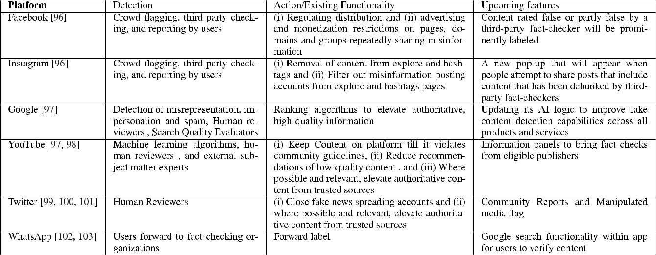

**TABLE 5.** Summary of global government-initiated interventions to combat fake news.

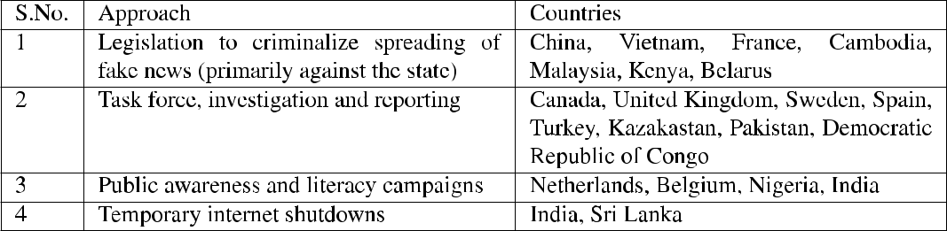

Governments contend that platforms run by the tech giants like Google and Facebook are equipped with the most advanced AI tools and competent workforce to be able to design and implement solutions to check the spread of fake news [104], [105]. The steps being taken by them seem more human-based and crowd-sourced rather than predominantly technology-driven. The use of human reviewers too can introduce individual biases and errors while classifying fake news or disinformation. Further, social media platforms have not taken decisive action against sponsored fake news, advertisements, and bots due to economic reasons. On the other hand, these platforms argue that content censorship in violation of user-privacy norms is not their stated agenda or responsibility. Traditional print or online media are equally susceptible to running sponsored advertisements that may be misleading in nature. All the social media platforms claim to have mechanisms in place to remove offensive content when reported by users and veri ed by them. Finally, potential user backlash against these platforms for violating their privacy and performing real-time fact-checks on their messages prevents them from adopting an aggressive strategy to detect and contain fake news.

**C. GOVERNMENT-LEVEL INTERVENTION**

Poynter [87] has documented different approaches to counter fake news spread by various national governments.

VOLUME 10, 2022

The national governments worldwide have taken initiatives to combat the menace of misinformation [106]. A summary of such interventions is presented in Table 5. Table 6 shows signi cant legislations for Combating fake news taken worldwide.

Government interventions however have not had the desired impact due to the following reasons [109] [112]:

1. Fake pro les on social media make it hard to pinpoint the perpetrators.
2. No feasible mechanism to actively track fake news on a multitude of platforms.
3. Understaffed cyber-security and social media monitor-ing cells in local police forces coupled with lack of training.
4. Lack of awareness of laws and legislation by both individuals and enforcement agencies.
5. Non-reporting by users.

It can be seen that governments have recognized the threat fake news pose to the modern world very late, and major legislative steps have been taken only post 2016 when the US Presidential Elections demonstrated how fake news propagated over social media can sway public opinion and in uence election outcomes. However, major drawbacks of heightened government curbs and monitoring of the social media space for individual users include violation of democratic and civil rights, including freedom

78279

A. Gupta *et al.*: Combating Fake News: Stakeholder Interventions and Potential Solutions

**TABLE 6.** Significant legislation for combating fake news world-wide.

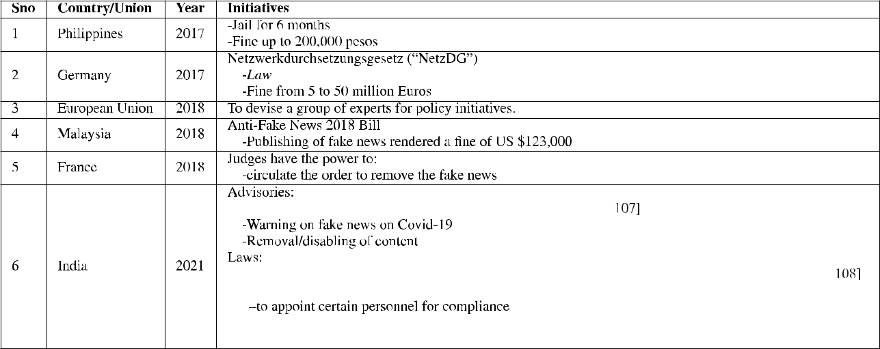

of expression, intrusion of privacy and misuse of laws to curb dissent [113].

**VII. TECH-MEDIATED SOLUTIONS FOR FAKE NEWS**

Different researchers have tried to categorise approaches to fake news detection and mitigation. In [8], Sharma *et al.* have categorized existing methods to stop fake news into three categories, namely content, feedback, and intervention-based solutions. The content-based identi cation includes cue and feature methods, linguistic analysis and deep learn-ing methods. Feedback-based identi cation includes using hand-picked features to identify fake news and analysing propagation patterns, temporal patterns, and user responses. Intervention-based solutions include computational methods and algorithms that interpret dynamically the actions to combat fake news, which is based on real-time content propagation dynamics. Zhou and Zafarani in [7] discussed different perspectives of fake news detection, which are based on knowledge, style, propagation, and source characteristics. Parikh and Atrey in [74] discussed ve categories of methods for detecting fake news, namely language features, deception modelling, clustering, predictive modelling, content cues and non-text cues-based methods. Zhang and Ghorbani in [70] described four categories of online fake news detection approaches: component-based (creator analysis, content anal-ysis and context analysis), data mining based (supervised and unsupervised), implementation-based (online and of ine) and platform-based (social media and another online news platform) categories.

The summary of the work done for detecting fake news is presented in Figure 6.

The individual approaches for fake news detection are discussed in detain below:

**A. USER ANALYSIS-BASED SOLUTIONS**

Users who participate in either creating or sharing fake news have been studied and mechanisms have been developed to identify them.

78280

**Bot Detection**: A signi cant difference has been observed between the bots and human population as detected from their Twitter activities [114]. Therefore, user behaviour analysis can be used to detect malicious activity in spreading fake news. Nasim *et al.* [115] developed a method to identify social bots on Twitter using only partial information about the user and their tweet history, in real-time exploiting temporal patterns and message diversity trends.

**User Credibility**: News shared by a credible user is more likely to be true, while news shared by a user with low credibility is less likely to be true. Determination of user credibility gives important clues to the veracity of the news item they share. User pro le features like location, pro le image, political bias to classify fake news are relevant to assess their credibility [116].

User pro le veri cation by social media platforms and mobile messaging applications is a simple, but effective mechanism to weed out fake pro les, prevent trolling, cyber-bullying and irresponsible sharing of content. User anonymity offered by current social media platforms remains the major reason for the propagation of fake news.

**B. CONTENT ANALYSIS-BASED SOLUTIONS**

Content analysis and review is of utmost importance in order to declare the news as fake or genuine accurately [117]. Some of the content analysis techniques are described as followsV

**Linguistic/Semantic Analysis**: Fake news is highly correlated with the use of emotional words and propagandistic content. Ajao *et al.* [118] proposed that there exists a relationship between fake information and emotional words. They improved the fake news detection using sentiment analysis and classi cation. To solve this, Sonia, *et al.* in [119] devised a agnostic classi cation scheme with language and web features for the identi cation of fake news. It extracts mor-phological, psychological, readability and web-markup

VOLUME 10, 2022

A. Gupta *et al.*: Combating Fake News: Stakeholder Interventions and Potential Solutions

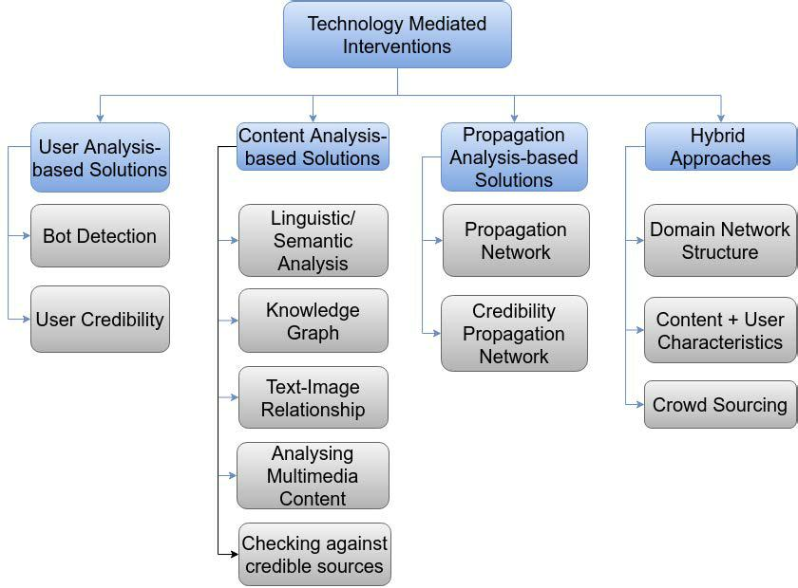

**FIGURE 6.** Categorization of types of technology mediated solutions for combating fake news.

features from webpages and classi es them as fake or genuine. CredEye [120] uses a language style and web search to analyze the credibility of a given textual claim.

**Knowledge Graph based**: A knowledge graph repre-sents a collection of interlinked descriptions of entities real-world objects, events, situations, or abstract con-cepts [121]. Pan *et al.* in [122] propose article-content based fake news detection by constructing a complete and precise knowledge graph to cover the fake news articles’ topic. They improved performance using pos-itive and negative knowledge graph embedding models once the complete and precise knowledge graphs were obtained from the article. Zhou, Zhixuan, *et al.* in [123] argue that purely linguistic approaches can potentially misclassify fake news. To address this, they propose to use fact-checking in conjunction with linguistic characteristics analysis by using a crowdsourced knowl-edge graph. ClaimsKG [124] is a semi-automatically generated knowledge graph of claims from major fact-checking services registered with IFCN.

**Text-Image Relationship**: There have been instances where the unrelated or often misleading image is used in conjunction with a news article, a characteristic of disinformation. Yang, Yang, *et al.* [125] have devised a text and image information based Convolutional Neural Network (TI-CNN) which predicts the veracity of a news article taking into consideration the image as well as the text with 92% precision, the dataset being the news about 2016 US presidential elections. InVid [126] is a browser plug-in tool that performs video

VOLUME 10, 2022

context analysis, Twitter search, keyframe selection, magni cation and gathers video metadata. It also provides forensic analysis of keyframes to help users nd if the frames have tampered.

**Analyzing Multimedia Content**: Deepfakes are gen-erated using Generative Adversarial Networks (GANs), which employ two DNNs, rst for generating a deepfake video and second for detecting it. The generating DNN learns how to produce undetectable videos throughout this adversarial game. MesoNet [127] is a network used for video forgery especially in facial features. It focuses on mesoscopic properties of images. Yuezun and Siwei [128] observed that DeepFake algorithms need that leave certain distinctive artifacts in the resulting video. They propose a CNN to detect the presence of such artifacts in the video frames. Sabir *et al.* [129] used existing recurrent convolutional networks to visually recognize and describe the images [130] with modi-cations to detect manipulations in the region of the image where face is present. They initially detect the face from video, crop it, and align the faces from video frames and manipulate the detection in the preprocessed region. However, there is always a scope for the current methods to be obsolete as the Deepfake GAN is updated with the newer detecting DNNs. Watermarking multimedia content for digital provenance is another way to protect against Deepfakes [131]. This, however, needs devices that capture audio and video being capable of digital watermarking. Simone *et al.* [132] describe audio tampering detection using multimodal features by

78281

A. Gupta *et al.*: Combating Fake News: Stakeholder Interventions and Potential Solutions

looking at the environmental characteristics estimated via an audio signal.

**Checking against Credible Sources**: Checking a piece of information against credible sources is the most traditional and sure-shot approach to assess its veracity. However, fact-checking is not so straightforward, given the variations in natural language used to express similar information.

1. **PROPAGATION ANALYSIS-BASED SOLUTIONS**

**Propagation Network**: The manner in which informa-tion spreads can provide insights into its veracity as true news and fake news follow distinguishable propagation patterns. Shu *et al.* [133] exploited hierarchical propa-gation network features to classify fake news. They use two levels of propagation networks: Macro-level - tweets posting pattern and information sharing pattern, and Micro-level - user conversations towards news pieces on social media over time. Social bots heavily support successful low-credibility sources. Yang *et al.* created a deep neural network model that can detect fake news in the rst 5 minutes of it starting to spread based only on user characteristics on Twitter [134]. The neural network is composed of Recurrent Neural Networks and Convolutional Neural Networks that represent the propagation path classi ed as that of fake news or otherwise. They have been able to early detect fake news on a Twitter dataset with an accuracy of 85%. TraceMiner [135] classi ed social media messages as fake or true based on their propagation pathway in the social network utilizing the LSTM-RNN model.

**Credibility Propagation Network**: Jin *et al.* [136] exploited the con icting social viewpoints in a credibil-ity propagation network to verify the news automatically in microblogs. They studied news microblog posts from Sina Weibo, observed the relationships among the interacting posts, and clustered them into supporting and opposing clusters. Supporting relationships enhance a tweet’s credibility, while opposing relationships decrease credibility.

1. **HYBRID APPROACHES**

Hybrid approaches combine user-analysis, content, and propagation-based approaches to detect fake news.

**Domain Network Structure**: Chen *et al.* [137] pre-sented a discovery system that proactively surfs web-sites using the domain network structure, which is reconstructed from social media feeds and classifying them using a topic-agnostic classi cation strategy (TAG) [119] as fake or true.

**Content and User Behavior**: Capture, Score, and Integrate (CSI) [76] is a deep hybrid model that takes the text of the news article as well as the promoters and the response it receives. The capture module takes the series of engagements and constructed a graph of these engagements by a score module. The output of

78282

both the modules is integrated to classify the news as reliable or not. Gupta *et al.* in [138] used ranking techniques to know the credibility of information on the Twitter. Their ranking scheme uses message-level features like length, unique characters, hashtags, swear language words, emoticons, etc.; and user-level features like age, number of statuses, veri ed account, length of description, URL characteristics, the ratio of followers to users followed, etc. FakeDetector [139] is a fake news detection system that extracts a both explicit and latent features from the text and builds a deep diffusive network model to represent news articles, creators, and subjects. It then determines relationships between creators, news articles, and the subject of the news article and learns to predict their credibility levels. FakeNewsTracker [140] is a system to understand and detect the fake news automatically. It employs the Social Article Fusion (SAF) model that utilizes language features of the news and social context to classify it as fake. Unique features of FakeNewsTracker are geo-visualization, social network visualization of fake news, and word cloud representation.

**Crowd Sourcing**: FeedRe ect [141] is a browser extension that nudges users to pay more attention and uses re ective questions to engage in news credibility assessment on Twitter. It intervenes on users’ Twitter feeds by highlighting content that requires careful assessment of credibility. Detective [142] leverages the crowd signals of users in social networks for detecting fake news. Interestingly, it learns user behavior in agging fake news in a social network and their accuracy

in agging.

While technology-based fake news detection schemes hold promise, the fact that none of these schemes is deployed in the real-world indicates that these schemes are unable to effectively address the challenges in detecting fake news. Some of the reasons why tech-mediated interventions for detecting fake news fail are listed belowV

1. These schemes are shown to work on very small subsets of real-world data sets, including content, which is temporally and spatially related, for instance, the US Presidential Elections. A generic solution that is able to detect fake news effectively at scale and in real-time would require access to all user-pro les and shared content and plenty of computational resources.
2. Most of the existing social network platforms are not open to third-party fake news detection services due to their privacy policies, rendering these solutions infeasible.
3. Technology interventions can be made to work seam-lessly if provided by the social network itself. However, as discussed earlier, there is very little incentive for these platforms to do so as it might alienate their userbase due to privacy concerns and lead to loss of advertisement revenue if advertisements are classi ed as misleading or potentially malicious.

VOLUME 10, 2022

A. Gupta *et al.*: Combating Fake News: Stakeholder Interventions and Potential Solutions

**TABLE 7.** Desirables satisfied by different types of solutions.

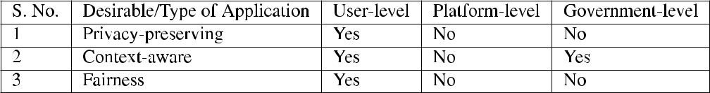

1. For mobile-messaging applications providing end-to-end encryption, it is impossible to track user-shared content making fake news detection a non-starter.
2. Detecting multimedia content manipulation in a purely automated manner is technically challenging given the scale at which multimedia content is generated and

shared.

Thus, a combination of economic considerations, privacy concerns, design of message sharing applications and largely closed nature of social networking platforms, severely restrict the effectiveness of pure technology-based fake news detection schemes.

**VIII. EXPLORING A VIABLE SOLUTION FOR CHECKING FAKE NEWS SPREAD**

As discussed in Section 5, any solution to combat fake news can be envisaged at the levels of the three primary actors, namely user-level (creator/consumer), platform-level (disseminating forum) and government-level (affected/responsible stakeholder). In an ideal world, all the actors would cooperate and build a viable solution centred around awareness (government), technology (platform) and self-regulation (user) [143], [144]. However, the relationship between the actors can be characterized by a lack of trust. On many occasions, governments have prosecuted their citizens for their social media posts [145], while platforms have also been accused of partisan behavior in selectively banning in uencers by categorizing their speech as hate speech [146] [148]. Due to this lack of trust, a viable technical solution spanning all actors remains infeasible. Therefore, to arrive at a viable solution, we specify the desirable characteristics of any solution with respect to their implementation at the level of the 3 actors in Table 7.

Privacy preservation is an essential aspect of any solution as users will not be comfortable knowing that the platform or the government is monitoring their personal pro les and keeping track of their posts. For platforms to detect fake news, they will need to access the pro les of individual users and analyze their posts. Other message sharing platforms like WhatsApp offering end-to-end encryption profess helplessness in accessing the information shared between users. Thus, there are severe technical challenges in building platform-centric solutions to detect fake news. The second desirable aspect for a viable solution is the context amalgamation of a user’s culture, language, region and local environment. For platforms to build user-speci c context for billions of users is technically intractable at present. Governments, too, would struggle to build technical

VOLUME 10, 2022

solutions to check for fake news at each geographic region or sub-region level within a country or state. Further, all such solutions would infringe on the individual user’s privacy. The third and nal desirable property for a viable solution is fairness or the implicit trust that the solution shall be free of any biases. On this aspect, both platform-level solutions and government-led solutions do not make the cut. Further, even AI-driven solutions are not completely free from bias. Thus, classifying news/information as fake, based on a solution that does not guarantee to be fair, shall not nd global acceptance.

Thus, a viable solution to prevent the spread of fake news at the user level can be envisaged to be an independent news veri cation service. An interface providing an in-app (for mobile message sharing applications) or in-platform (for social networking platforms) access to an independent news-veri cation service for the end-users. This service shall empower end users to ascertain the authenticity of any news item they come across on social media or deliver as a message to them.

However, it is not trivial to build a credible news-veri cation service. There are several technical challenges, including dynamic knowledge bases, which are constantly updated, new intervention strategies for different envi-ronments and credible datasets for intent detection [8]. The news-veri cation service can be envisaged to be a context-speci c database of credible news information organized hierarchically according to location and trending topics. A schematic of the envisaged solution is presented in Figure 7.

The user invokes the news-veri cation Client whenever she wants to fact-check a message, post or any given text. The Natural Language Processing (NLP) Module extracts the location, entity, context, and sentiment from the given text and sends the extracted parameters to the location-speci c news-veri cation service based on the location of the user or the location extracted from the message text to be veri ed. So, news pertaining to Delhi, India, shall be routed to the news-veri cation service for Delhi, India.

The Content Classi er creates a database of authentic information, the Credible News DB, from trusted sources based upon location, entity, context and sentiment using NLP and Cognitive Computing tools. Within a particular news-veri cation service, news from credible sources is sorted by various entities (people, places), topics, latest news, trending news and cached results for previous fact-check queries. The trusted sources include websites and RSS feeds of credible news websites, as well as their veri ed and trusted social media handles. Matching news is ranked based on their

78283

A. Gupta *et al.*: Combating Fake News: Stakeholder Interventions and Potential Solutions

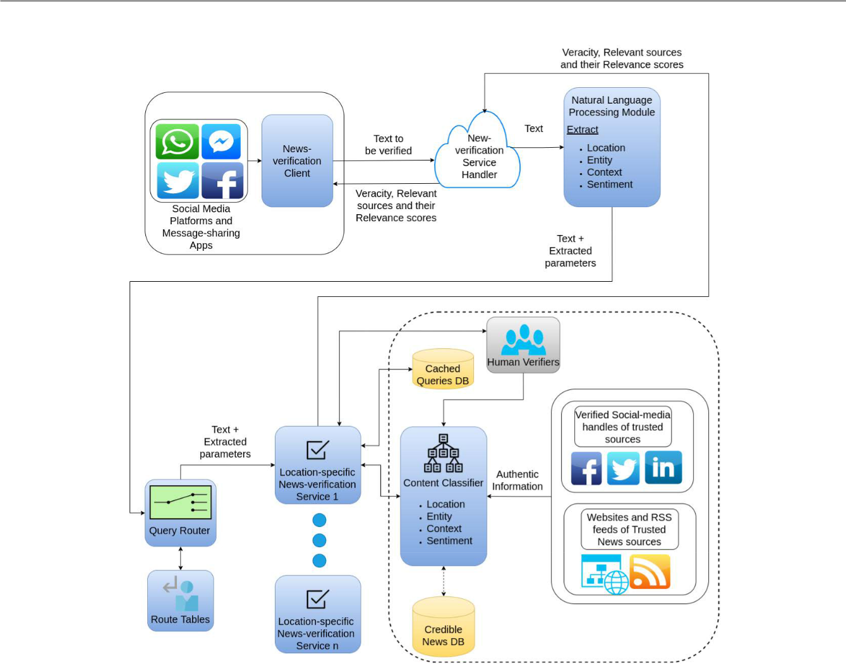

**FIGURE 7.** Schematic for a user-initiated news-verification service as a suggested viable solution for checking fake news spread.

relevance, giving them a relevance/veracity score. In case no relevant information regarding the given text is found in the Credible News DB, the text is sent to human veri ers for veri cation.

Thus, end-users will be able to verify news received and probably desist from blindly believing received content and forwarding it indiscriminately. This will help break the chain and slow down the spread of fake news. Combined with effective awareness campaigns, it can emerge as a strong tool to check the spread of fake news. Such a service can be reliably hosted if local administrations, news agencies and prominent citizens join hands to tackle the fake news menace.

**IX. OPEN ISSUES AND CHALLENGES**

While a Suggested Viable Solution is described in this paper, this domain of knowledge needs more research. As we have diverse platforms, multimedia, captivating Virtual Real-ity (VR) and Augmented Reality (AR), Metaverse [149] and Omniverse [150], fake news nds more impactful platforms. The fake news characteristics need to be studied in detail for these new mediums. Following are the open issues and challenges that we identifyV

Creation of unbiased datasets for news veri cation

Increasing complexity of multimedia content. New forms of multimedia content.

User privacy.

Verifying multimedia content is an open technical challenge.

Tradeoff between user privacy and news veri cation.

Maintaining consistency between cross-nation and cross-cultural fake news understanding and law imple-mentation.

1. **CONCLUSION**

Fake news detection and mitigation remain one of the most challenging problems to solve due to many factors human, technical and economical- which preclude a generic technology-enabled solution from being formulated and deployed. Further, human and AI-generated multimedia content is adding immense complexity in detecting the spread of fake news. Social networking platforms and mobile messaging applications are under increased scrutiny and pressure by Governments and law-enforcement agencies worldwide in helping track users shared content and perpetra-tors of fake news in the interest of national security and law and order. While technology solutions developed by the social

78284 VOLUME 10, 2022

A. Gupta *et al.*: Combating Fake News: Stakeholder Interventions and Potential Solutions

networking platforms and mobile messaging applications to detect malicious content themselves are most feasible, user privacy will need to be compromised to achieve it. A balance between free speech, user rights and the interests of the society and nations at large seems hard to achieve. In the current scenario, a viable solution seems to be in-app or in-platform access to an independent news-veri cation service that allow users to verify content on-demand. However, building a reliable news-veri cation service is non-trivial as it is location-based and covers diverse topics and individ-uals. Further, verifying multimedia content such as videos, photographs and audio clips remains an open technical challenge for ongoing research. Till then, a multi-modal approach combining user awareness campaigns, government legislation, increased checks and balances at the platform level involving user veri cation, authentication, controlled sharing and nally news-veri cation service backed by a consortium of credible news agencies can help alleviate the menace somewhat.

In the future, we will implement the proposed solution and evaluate its performance based on various evaluation metrics.

**REFERENCES**

1. *How to Avoid Coronavirus Fake News? World Economic Forum*. Accessed: Aug. 29, 2021. [Online]. Available: https://www.weforum.org/ agenda/2020/03/how-to-avoid-covid-19-fake-news-coronavirus/
2. *Fake News Big Impediment in Fighting COVID-19 Pandemic, Centre Tells SC, India News Times of India*. Accessed: Aug. 29, 2021. [Online]. Available: https://timeso ndia.indiatimes.com/india/fake-news-big-impediment-in- ghting-covid-19-pandemic-centre-tells-sc/articleshow/74918391.cms
3. T. D. N. de Barcelos, L. N. Muniz, D. M. Dantas, D. F. Cotrim Junior, J. R. Cavalcante, and E. Faerstein, ‘‘AnÆlise de fake news veiculadas durante a pandemia de COVID-19 no Brasil,’’ *Revista Panamericana de Salud Pœblica*, vol. 45, p. e65, Jun. 2021.
4. D. Carrion-Alvarez and P. X. Tijerina-Salina, ‘‘Fake news in COVID-19: A perspective,’’ *Health Promotion Perspect.*, vol. 10, no. 4, p. 290, 2020.
5. F. Simon, P. N. Howard, and R. K. Nielsen. *Types, Sources, and Claims of COVID-19 Misinformation*. Accessed: Jul. 4, 2020. [Online]. Avail-able: https://reutersinstitute.politics.ox.ac.uk/types-sources-and-claims-covid-19-misinformation
6. *A Brief History of Fake News, Center for Information Technology and Society UC Santa Barbara*. Accessed: Aug. 31, 2021. [Online]. Available: https://www.cits.ucsb.edu/fake-news/brief-history
7. X. Zhou and R. Zafarani, ‘‘A survey of fake news: Fundamental theories, detection methods, and opportunities,’’ *ACM Comput. Surv.*, vol. 53, no. 5, pp. 1 40, 2020.
8. K. Sharma, F. Qian, H. Jiang, N. Ruchansky, M. Zhang, and Y. Liu, ‘‘Combating fake news: A survey on identi cation and mitigation techniques,’’ *ACM Trans. Intell. Syst. Technol.*, vol. 10, no. 3, pp. 1 42, 2019.
9. A. Bondielli and F. Marcelloni, ‘‘A survey on fake news and rumour detection techniques,’’ *Inf. Sci.*, vol. 497, pp. 38 55, Sep. 2019.
10. T. Zubair, A. Raquib, and J. Qadir, ‘‘Combating fake news, misinforma-tion, and machine learning generated fakes: Insight’s from the Islamic ethical tradition,’’ *ICR J.*, vol. 10, no. 2, pp. 189 212, Dec. 2019.
11. I. Hassan, M. N. L. Azmi, and A. M. Abdullahi, ‘‘Evaluating the spread of fake news and its detection. Techniques on social networking sites,’’ *Romanian J. Commun. Public Relations*, vol. 22, no. 1, pp. 111 125,2020.
12. S. Hakak, W. Z. Khan, S. Bhattacharya, G. T. Reddy, and K.-K. R. Choo, ‘‘Propagation of fake news on social media: Challenges and opportunities,’’ in *Proc. 9th Int. Conf. Comput. Data Social Netw.*, Dallas, TX, USA. Berlin, Germany: Springer-Verlag, Dec. 2020, pp. 345 353, doi: [10.1007/978-3-030-66046-8_28.](http://dx.doi.org/10.1007/978-3-030-66046-8_28)

VOLUME 10, 2022

1. A. R. Sana Ullah, A. Das, A. Das, M. Ashad Kabir, and K. Shu, ‘‘A survey of COVID-19 misinformation: Datasets, detection techniques and open issues,’’ 2021, *arXiv:2110.00737*.
2. J. Ayoub, X. J. Yang, and F. Zhou, ‘‘Combat COVID-19 infodemic using explainable natural language processing models,’’ *Inf. Process. Manage.*, vol. 58, no. 4, Jul. 2021, Art. no. 102569.
3. W. Ansar and S. Goswami, ‘‘Combating the menace: A survey on characterization and detection of fake news from a data science perspective,’’ *Int. J. Inf. Manage. Data Insights*, vol. 1, no. 2, Nov. 2021, Art. no. 100052.
4. B. Collins, D. T. Hoang, N. T. Nguyen, and D. Hwang, ‘‘Trends in combating fake news on social media A survey,’’ *J. Inf. Telecommun.*, vol. 5, no. 2, pp. 247 266, 2021.
5. W. Shahid, B. Jamshidi, S. Hakak, H. Isah, W. Z. Khan, M. K. Khan, and K.-K.-R. Choo, ‘‘Detecting and mitigating the dissemination of fake news: Challenges and future research opportunities,’’ *IEEE Trans. Computat. Social Syst.*, early access, Jun. 6, 2022, doi: [10.1109/TCSS.2022.3177359.](http://dx.doi.org/10.1109/TCSS.2022.3177359)
6. W. Shahid, Y. Li, D. Staples, G. Amin, S. Hakak, and A. Ghorbani, ‘‘Are you a cyborg, bot or human? A survey on detecting fake news spreaders,’’ *IEEE Access*, vol. 10, pp. 27069 27083, 2022.
7. I. Varlamis, D. Michail, F. Glykou, and P. Tsantilas, ‘‘A survey on the use of graph convolutional networks for combating fake news,’’ *Future Internet*, vol. 14, no. 3, p. 70, Feb. 2022.
8. C. Zheng and X. Ma, ‘‘Evaluating the effect of enhanced text-visualization integration on combating misinformation in data story,’’ in *Proc. IEEE 15th Paci c Vis. Symp. (Paci cVis)*, Apr. 2022, pp. 141 150.
9. A. D’Ulizia, M. C. Caschera, F. Ferri, and P. Grifoni, ‘‘Fake news detection: A survey of evaluation datasets,’’ *PeerJ Comput. Sci.*, vol. 7, p. e518, Jun. 2021.
10. D. Rohera, H. Shethna, K. Patel, U. Thakker, S. Tanwar, R. Gupta, W.-C. Hong, and R. Sharma, ‘‘A taxonomy of fake news classi cation techniques: Survey and implementation aspects,’’ *IEEE Access*, vol. 10, pp. 30367 30394, 2022.
11. *News, Meaning in the Cambridge English Dictionary*. Accessed: Aug. 29, 2021. [Online]. Available: https://dictionary.cambridge.org/ dictionary/english/news
12. *Fake News, Meaning in the Cambridge English Dictionary*. Accessed: Aug. 29, 2021. [Online]. Available: https://dictionary.cambridge.org/ dictionary/english/fake-news
13. *House of Commons: Disinformation and ‘Fake News’: Final Report*.

Accessed: Jun. 24, 2022. [Online]. Available: https://publications. parliament.uk/pa/cm201719/cmselect/cmcumeds/1791/1791.pdf

1. T. Dame Adjin-Tettey, ‘‘Combating fake news, disinformation, and misinformation: Experimental evidence for media literacy education,’’ *Cogent Arts Humanities*, vol. 9, no. 1, Dec. 2022, Art. no. 2037229.
2. *Information Disorder*. Accessed: Sep. 9, 2021. [Online]. Available: https://www.coe.int/en/web/freedom-expression/information-disorder
3. *Newsmedialit_Fakenews_8.5X11*. Accessed: Aug. 29, 2021. [Online].

Available: https://d1e2bohyu2u2w9.cloudfront.net/education/sites/ default/ les/tlr-asset/newsmedialit_fakenewstimeline_8.5x11.pdf

1. *History of Fake News Fake News Libguides at Newcastle University*. Accessed: Aug. 29, 2021. [Online]. Available: https://libguides.ncl.ac.uk/ fakenews/history
2. P. Bhattacharya, S. B. Patel, R. Gupta, S. Tanwar, and J. J. P. C. Rodrigues, ‘‘SaTYa: Trusted Bi-LSTM-Based fake news classi cation scheme for smart community,’’ *IEEE Trans. Computat. Social Syst.*, early access, Dec. 10, 2021, doi: [10.1109/TCSS.2021.3131945.](http://dx.doi.org/10.1109/TCSS.2021.3131945)
3. F. Sa eddine, ‘‘History of fake news,’’ in *Fake News in an Era of Social Media: Tracking Viral Contagion*. Lanham, MD, USA: Rowman& Little eld, 2020, ch. 1.
4. *French Revolution: Timeline, Causes & Summary*. Accessed:

Feb. 4, 2021. [Online]. Available: https://www.britannica.com/event/ French-Revolution

1. W. J. Campbell, *Yellow Journalism*. Hoboken, NJ, USA: Wiley, 2019, pp. 1 5.
2. V. G. Walden, ‘‘Understanding holocaust memory and education in the digital age: Before and after covid-19,’’ *Holocaust Stud.*, vol. 28, no. 3, pp. 257 278, Jul. 2022.
3. T. Paddock, *World War I and Propaganda*. Leiden, The Netherlands: Brill, Jan. 2014.
4. (Sep. 2021). *Fake News in World War Two*. Accessed: Sep. 5, 2021.

[Online]. Available: https://www.historyextra.com/period/second-world-war/fake-news-world-war-two-henry-hemming/

78285

A. Gupta *et al.*: Combating Fake News: Stakeholder Interventions and Potential Solutions

1. C. H. Wilson, ‘‘Hitler, goebbels, and the ministry for propaganda,’’ *Political Quart.*, vol. 10, no. 1, pp. 83 99, Jan. 1939.
2. (Jul. 2019). *Establishing the Truth: Vaccines, Social Media, and the*

*Spread of Misinformation*. Accessed: Sep. 18, 2021. [Online]. Avail-

able: https://www.hsph.harvard.edu/ecpe/vaccines-social-media-spread-misinformation/

1. H. Allcott and M. Gentzkow, ‘‘Social media and fake news in the 2016 election,’’ *J. Econ. Perspect.*, vol. 31, no. 2, pp. 36 211, 2017.
2. *A Viral Rumor That Mcdonald’s Uses Ground Worm Filler in Burgers Has Been Debunked, Business Insider India*. Accessed: Aug. 29, 2021. [Online]. Available: https://www.businessinsider.in/retail/a-viral-rumor-that-mcdonalds-uses-ground-worm- ller-in-burgers-has-been-debunked/articleshow/50676282.cms
3. *Brexit: The False, Misleading and Suspicious Claims Crosscheck Has*

*Uncovered so Far*. Accessed: Aug. 29, 2021. [Online]. Available: https:// rstdraftnews.org/articles/brexit-the-false-misleading-and-suspicious-claims-crosscheck-has-uncovered/

1. *Whatsapp-Misinformation-Report*. Accessed: Aug. 29, 2021. [Online].

Available: https://www.lse.ac.uk/media-and-communications/assets/ documents/research/projects/WhatsApp-Misinformation-Report.pdf

1. M. Weerawardana and T. Fernando, ‘‘Deepfakes detection methods: A literature survey,’’ in *Proc. 10th Int. Conf. Inf. Autom. Sustainability (ICIAfS)*, Aug. 2021, pp. 76 81.
2. *Lyrebird Descript*. Accessed: Aug. 29, 2021. [Online]. Available: https://www.descript.com/lyrebird
3. K. Sheth, K. Patel, H. Shah, S. Tanwar, R. Gupta, and N. Kumar, ‘‘A taxonomy of AI techniques for 6G communication networks,’’ *Comput. Commun.*, vol. 161, pp. 279 303, Sep. 2020.
4. S. Singh, ‘‘Fighting fake information is a societal challenge: Chris Daniels, WhatsApp,’’ *Econ. Times*, Oct. 2018.
5. (Mar. 2021). *Fake News. It’s Complicated*. Accessed: Sep. 18, 2021.

[Online]. Available: https://medium.com/1st-draft/fake-news-its-complicated-d0f773766c79

1. C. Ireton and J. Posetti, *Journalism, Fake News & Disinformation: Handbook for Journalism Education and Training*. Paris, France: UnescoPublishing, 2018.
2. A. de Regt, M. Montecchi, and S. Lord Ferguson, ‘‘A false image of health: How fake news and pseudo-facts spread in the health and beauty industry,’’ *J. Product Brand Manage.*, vol. 29, no. 2, pp. 168 179, Aug. 2019.
3. V. L. Rubin, ‘‘Disinformation and misinformation triangle,’’ *J. Documen-tation*, vol. 75, no. 5, pp. 1013 1034, Sep. 2019.
4. *Why is Fake News Created? Fake News Research Guides at Madison College (Madison Area Technical College)*. Accessed: Aug. 31, 2021. [Online]. Available: https://libguides.madisoncollege.edu/fakenews

[52] (Nov. 2011). *What are the Three Main Parts of a News Story*. Accessed: Sep. 5, 2021. [Online]. Available:

https://www.preservearticles.com/journalism/what-are-the-three-main-parts-of-a-news-story/15738

1. T. Stafford. (Sep. 2021). *Psychology: Why Bad News Dominates*

*the Headlines*. Accessed: Sep. 5, 2021. [Online]. Available: https:// www.bbc.com/future/article/20140728-why-is-all-the-news-bad

1. *Study: 86% of People Don’t Fact Check News Spotted on Social*

*Media, PR Week*. Accessed: Aug. 29, 2021. [Online]. Available: https://www.prweek.com/article/1431578/study-86-people-dont-fact-check-news-spotted-social-media

1. C. Beckett, ‘‘‘Fake news’: The best thing that’s happened to

journalism,’’ *POLIS: Journalism Soc. LSE*, pp. 1 5, Sep. 2021.

[Online]. Available: http://eprints.lse.ac.uk/76568/1/blogs.lse.ac.uk-Fake%20news%20the%20best%20thing%20thats%20happened%20to% 20journalism.pdf

1. S. S. Sundar, M. D. Molina, and E. Cho, ‘‘Seeing is believing: Is video modality more powerful in spreading fake news via online messaging apps?’’ *J. Comput.-Mediated Commun.*, vol. 26, no. 6, pp. 301 319, Aug. 2021.
2. *Beware of Trolls Peddling Fake News Times of India*. Accessed: Aug. 29, 2021. [Online]. Available: https://timeso ndia.indiatimes.com/ viral-news/beware-of-trolls-peddling-fake-news/articleshow/63940993.cms
3. *Social Media Firms Fail to Act on COVID-19 Fake News BBC News*. Accessed: Aug. 29, 2021. [Online]. Available: https://www.bbc.com/ news/technology-52903680

78286

1. *Social Network Analysis Reveals Full Scale of Kremlin’s Twitter Bot Campaign Global Voices*. Accessed: Aug. 29, 2021. [Online]. Available: https://globalvoices.org/2015/04/02/analyzing-kremlin-twitter-bots/2/
2. *Fake News is Not the Only Problem, by Gilad Lotan, Data & Society: Points*. Accessed: Aug. 29, 2021. [Online]. Available: https://points.datasociety.net/fake-news-is-not-the-problem-f00ec8cdfcb
3. P. E. Converse, ‘‘The structure of belief systems in mass publics,’’ in *Ideology Discontent*. New York, NY, USA: Free Press, 1964,
   1. 206 261.
4. G. Pennycook and D. G. Rand, ‘‘Who falls for fake news? The roles of bullshit receptivity, overclaiming, familiarity, and analytic thinking,’’ *J. Personality*, vol. 88, no. 2, pp. 185 200, Apr. 2020.
5. *Filter Bubble, Meaning in the Cambridge English Dictionary*. Accessed: Aug. 29, 2021. [Online]. Available: https://dictionary.cambridge. org/dictionary/english/ lter-bubble
6. *Eli Pariser: Beware Online ‘Filter Bubbles’ Ted Talk*. Accessed:

Aug. 29, 2021. [Online]. Available: https://www.ted.com/talks/eli_ pariser_beware_online_ lter_bubbles

1. B. Bago, D. G. Rand, and G. Pennycook, ‘‘Fake news, fast and slow: Deliberation reduces belief in false (but not true) news headlines,’’ *J. Exp. Psychol., Gen.*, vol. 149, no. 8, p. 1608, 2020.
2. R. Marchi, ‘‘With Facebook, blogs, and fake news, teens reject journalis-tic ‘objectivity,’’’ *J. Commun. Inquiry*, vol. 36, no. 3, pp. 246 262, 2012.
3. N. Kshetri and J. Voas, ‘‘The economics of ‘fake news,’’’ *IT Prof.*, vol. 19, no. 6, pp. 8 12, 2017.
4. N. Srnicek, ‘‘The challenges of platform capitalism: Understanding the logic of a new business model,’’ *Juncture*, vol. 23, no. 4, pp. 254 257, Mar. 2017.
5. *Attention Economics and Fake News, Hippo Reads*. Accessed: Aug. 30, 2021. [Online]. Available: http://hipporeads.com/attention-economics-and-fake-news/
6. X. Zhang and A. A. Ghorbani, ‘‘An overview of online fake news: Characterization, detection, and discussion,’’ *Inf. Process. Manage.*, vol. 57, no. 2, Mar. 2020, Art. no. 102025.
7. J. M. Burkhardt, *Combating Fake News in the Digital Age* (Library Technology Reports), vol. 53, no. 8. Chicago, IL, USA: ALA TechSource, Nov./Dec. 2017.
8. A. Thota, P. Tilak, S. Ahluwalia, and N. Lohia, ‘‘Fake news detection: A deep learning approach,’’ *SMU Data Sci. Rev.*, vol. 1, no. 3, p. 10, 2018.
9. W. Yang Wang, ‘‘‘Liar, liar pants on re’: A new benchmark dataset for fake news detection,’’ 2017, *arXiv:1705.00648*.
10. S. B. Parikh and P. K. Atrey, ‘‘Media-rich fake news detection: A survey,’’ in *Proc. IEEE Conf. Multimedia Inf. Process. Retr. (MIPR)*, Apr. 2018,
    1. 436 441.
11. F. Monti, F. Frasca, D. Eynard, D. Mannion, and M. M. Bronstein, ‘‘Fake news detection on social media using geometric deep learning,’’ 2019, *arXiv:1902.06673*.
12. N. Ruchansky, S. Seo, and Y. Liu, ‘‘CSI: A hybrid deep model for fake news detection,’’ in *Proc. ACM Conf. Inf. Knowl. Manage.*, 2017,
    1. 797 806.
13. X. Zhou, A. Jain, V. V. Phoha, and R. Zafarani, ‘‘Fake news early detection: A theory-driven model,’’ *Digit. Threats: Res. Pract.*, vol. 1, no. 2, pp. 1 25, 2020.
14. K. Shu, L. Cui, S. Wang, D. Lee, and H. Liu, ‘‘dEFEND: Explainable fake news detection,’’ in *Proc. 25th ACM SIGKDD Int. Conf. Knowl. Discovery Data Mining*, 2019, pp. 395 405.
15. S. Mohseni, E. Ragan, and X. Hu, ‘‘Open issues in combating fake news: Interpretability as an opportunity,’’ 2019, *arXiv:1904.03016*.
16. *Social Media Veri cation Fact Checking & Veri cation for Reporting Libguides at Cuny Graduate School of Journalism*. Accessed: Aug. 30, 2021. [Online]. Available: https://researchguides. journalism.cuny.edu/factchecking-veri cation/UGC-veri cation
17. S. Michaels, ‘‘How many languages are there in the world?’’ in *Proc. WorldAtlas*, Jun. 2019. [Online]. Available: https://www.worldatlas.com/articles/how-many-languages-are-there-in-the-world.html
18. J. C. S. Reis, P. de Freitas Melo, K. Garimella, and F. Benevenuto, ‘‘Can WhatsApp bene t from debunked fact-checked stories to reduce misinformation?’’ 2020, *arXiv:2006.02471*.
19. K. Shu, A. Bhattacharjee, F. Alatawi, T. H. Nazer, K. Ding, M. Karami, and H. Liu, ‘‘Combating disinformation in a social media age,’’ *Wiley Interdiscipl. Rev., Data Mining Knowl. Discovery*, vol. 10, no. 6, p. e1385,2020.

VOLUME 10, 2022

A. Gupta *et al.*: Combating Fake News: Stakeholder Interventions and Potential Solutions

1. M. Groh, Z. Epstein, N. Obradovich, M. Cebrian, and I. Rahwan, ‘‘Human detection of machine-manipulated media,’’ *Commun. ACM*, vol. 64, no. 10, pp. 40 47, Oct. 2021.
2. `. Figueira and L. Oliveira, ‘‘The current state of fake news: Challenges and opportunities,’’ *Proc. Comput. Sci.*, vol. 121, pp. 817 825, Jan. 2017.
3. D. M. Lazer, M. A. Baum, Y. Benkler, and A. J. Berinsky, ‘‘The science of fake news,’’ *Science*, vol. 359, no. 6380, pp. 1094 1096, 2018.
4. *A Guide to Anti-Misinformation Actions Around the World Poynter*. Accessed: Aug. 30, 2021. [Online]. Available: https://www.poynter.org/ ifcn/anti-misinformation-actions/
5. *Fact-Checking Your Reporting Fact Checking & Veri cation for Reporting Libguides at Cuny Graduate School of Journalism*. Accessed: Aug. 30, 2021. [Online]. Available: https://researchguides. journalism.cuny.edu/factchecking-veri cation/fact-check-your-work
6. *How we Identify Fact-Checkers Duke Reporters’ Lab*. Accessed: Aug. 30, 2021. [Online]. Available: https://reporterslab.org/how-we-identify-fact-checkers/
7. *International Fact-Checking Network Poynter*. Accessed: Aug. 30, 2021. [Online]. Available: https://www.poynter.org/ifcn/
8. *IFCN Code of Principles*. Accessed: Aug. 30, 2021. [Online]. Available: https://ifcncodeofprinciples.poynter.org/signatories
9. *Methodology for Fact Checking Alt News*. Accessed: Aug. 30, 2021.

[Online]. Available: https://www.altnews.in/methodology-for-fact-checking/

1. *Politifact*. Accessed: Aug. 30, 2021. [Online]. Available: https://www. politifact.com/
2. *Apo-Nid76233.Pdf*. Accessed: Sep. 26, 2021. [Online]. Available: https://apo.org.au/sites/default/ les/resource- les/2017-05/apo-nid76233.pdf
3. T. Khan and A. Michalas, ‘‘Trust and believe should we? Evaluating the trustworthiness of Twitter users,’’ in *Proc. IEEE 19th Int. Conf. Trust, Secur. Privacy Comput. Commun. (TrustCom)*, Dec. 2020,pp. 1791 1800.
4. *Preparing for Elections, About Facebook*. Accessed: Aug. 30, 2021.

[Online]. Available: https://about.facebook.com/actions/preparing-for-elections-on-facebook/

1. *How Google Fights Disinformation*. Accessed: Aug. 30, 2021.

[Online]. Available: https://kstatic.googleusercontent.com/ les/ 388aa7d18189665e5f5579aef18e181c2d4283fb7b0d4691689dfd1bf92f 7ac2ea6816e09c02eb98d5501b8e5705ead65af653cdf94071c4736 1821e362da55b

1. *Youtube: Fighting Fake News: Youtube to Show ‘Information Panels’ on*

*News-Related Videos The Economic Times*. Accessed: Aug. 30, 2021.

[Online]. Available: https://economictimes.indiatimes.com/magazines/ panache/ ghting-fake-news-youtube-to-show-information-panels-on-news-related-videos/articleshow/68302365.cms

1. *Twitter Con rms it is Working on These Features to Fight Spreading of Misinformation, HT Tech*. Accessed: Aug. 30, 2021. [Online]. Available: https://tech.hindustantimes.com/tech/news/twitter-con rms-it-is-workig-on-these-features-to- ght-spreading-of-misinformation-story-uHhcMttunfGwsIRsm4mD2N.html
2. *Twitter Shuts Thousands of Fake News Accounts Worldwide Fighting Fake News, the Economic Times*. Accessed: Aug. 30, 2021. [Online]. Available: https://economictimes.indiatimes.com/tech/twitter-shuts-thousands-of-fake-news-accounts-worldwide/ ghting-fake-news/slideshow/71221225.cms
3. *Our Range of Enforcement Options for Violations, Twitter Help*. Accessed: Aug. 30, 2021. [Online]. Available: https://help.twitter. com/en/rules-and-policies/enforcement-options
4. *Whatsapp Help Center IFCN Fact Checking Organizations on Whatsapp*. Accessed: Aug. 30, 2021. [Online]. Available: https://faq. whatsapp.com/general/ifcn-fact-checking-organizations-on-whatsapp/?lang=en
5. *16 Ways Fact-Checkers and Users Can Debunk Hoaxes on Whatsapp, IFCD*. Accessed: Aug. 30, 2021. [Online]. Available: https://factcheckingday.com/articles/14/16-ways-fact-checkers-and-users-can-debunk-hoaxes-on-whatsapp
6. *Google, Facebook Twitter Grilled in us on Fake News BBC News*. Accessed: Sep. 26, 2021. [Online]. Available: https://www.bbc. com/news/technology-56523378
7. *Facebook, Google, Twitter Need to do More to Tackle Fake News EU Says*. Accessed: Sep. 26, 2021. [Online]. Available: https://www.cnbc. com/2019/06/14/facebook-google-twitter-need-to-do-more-to-tackle-fake-news-eu-says.html

VOLUME 10, 2022

1. *How Governments Can Take Actions Against Fake News Propensity*. Accessed: May 4, 2021. [Online]. Available: https://www.hec.edu/en/ knowledge/articles/how-governments-can-take-actions-against-fake-news-propensity
2. *Meity Advisory TP Social Media on Corona_07May2021*. Accessed: Feb. 26, 2022. [Online]. Available: https://www.meity.gov.in/ writereaddata/ les/MeitY_advisory_to_Social_Media_on_Corona_ 07May2021.pdf
3. *The information technology (intermediary guidelines and Digital Media Ethics Code) Rules, 2021*. Accessed: Feb. 26, 2022. [Online]. Available: https://prsindia.org/billtrack/the-information-technology-intermediary-guidelines-and-digital-media-ethics-code-rules-2021
4. *A Wave of Fake Social Media Accounts*. Accessed: Sep. 27, 2021.

[Online]. Available: https://www.cyber.gov.au/acsc/view-all-content/ news/wave-fake-social-media-accounts

1. T. Khan, A. Michalas, and A. Akhunzada, ‘‘Fake news outbreak 2021: Can we stop the viral spread?’’ *J. Netw. Comput. Appl.*, vol. 190, Sep. 2021, Art. no. 103112.
2. *61% of Cybersecurity Teams are Understaffed Help Net Security*. Accessed: Sep. 26, 2021. [Online]. Available: https:// www.helpnetsecurity.com/2021/05/05/understaffed-cybersecurity-teams/
3. D. O. Klein and J. R. Wueller, ‘‘Fake news: A legal perspective,’’ *Australas. Policing*, vol. 10, no. 2, pp. 1 10, 2018.
4. *LSE MPP Policy Brief 20 Fake News_Final.Pdf*. Accessed: Sep. 26, 2021. [Online]. Available: http://eprints.lse.ac.uk/73015/1/ LSE%20MPP%20Policy%20Brief%2020%20-%20%Fake%20news_ nal.pdf
5. A. Duh, M. Slak Rupnik, and D. Koro†ak, ‘‘Collective behavior of social bots is encoded in their temporal Twitter activity,’’ *Big Data*, vol. 6, no. 2,
   1. 113 123, Jun. 2018.
6. M. Nasim, A. Nguyen, N. Lothian, R. Cope, and L. Mitchell, ‘‘Real-time detection of content polluters in partially observable Twitter networks,’’ in *Proc. Companion The Web Conf. Web Conf. (WWW)*, 2018,
   1. 1331 1339.
7. K. Shu, X. Zhou, S. Wang, R. Zafarani, and H. Liu, ‘‘The role of user pro les for fake news detection,’’ in *Proc. IEEE/ACM Int. Conf. Adv. Social Netw. Anal. Mining*, Aug. 2019, pp. 436 439.
8. S. Sepasgozar, R. Karimi, L. Farahzadi, F. Moezzi, S. Shirowzhan, S. M. Ebrahimzadeh, F. Hui, and L. Aye, ‘‘A systematic content review of arti cial intelligence and the Internet of Things applications in smart home,’’ *Appl. Sci.*, vol. 10, no. 9, p. 3074, Apr. 2020.
9. O. Ajao, D. Bhowmik, and S. Zargari, ‘‘Sentiment aware fake news detection on online social networks,’’ in *Proc. IEEE Int. Conf. Acoust., Speech Signal Process. (ICASSP)*, May 2019, pp. 2507 2511.
10. S. Castelo, T. Almeida, A. Elghafari, A. Santos, K. Pham, E. Nakamura, and J. Freire, ‘‘A topic-agnostic approach for identifying fake news pages,’’ in *Proc. Companion Proc. World Wide Web Conf.*, May 2019,
    1. 975 980.
11. K. Popat, S. Mukherjee, J. Strötgen, and G. Weikum, ‘‘CredEye: A credibility lens for analyzing and explaining misinformation,’’ in *Proc. Companion Web Conf.*, 2018, pp. 155 158.
12. *What is a Knowledge Graph? Ontotext Fundamentals*. Accessed: Aug. 30, 2021. [Online]. Available: https://www. ontotext.com/knowledgehub/fundamentals/what-is-a-knowledge-graph/
13. J. Z. Pan, S. Pavlova, C. Li, N. Li, Y. Li, and J. Liu, ‘‘Content based fake news detection using knowledge graphs,’’ in *Proc. Int. Semantic Web Conf.* Cham, Switzerland: Springer, 2018, pp. 669 683.
14. Z. Zhou, H. Guan, M. Moorthy Bhat, and J. Hsu, ‘‘Fake news detection via NLP is vulnerable to adversarial attacks,’’ 2019, *arXiv:1901.09657*.
15. A. Tchechmedjiev, P. Fafalios, K. Boland, M. Gasquet, M. Zloch, B. Zapilko, S. Dietze, and K. Todorov, ‘‘ClaimsKG: A knowledge graph of fact-checked claims,’’ in *Proc. Int. Semantic Web Conf.* Cham, Switzerland: Springer, 2019, pp. 309 324.
16. Y. Yang, L. Zheng, J. Zhang, Q. Cui, Z. Li, and P. S. Yu, ‘‘TI-CNN: Convolutional neural networks for fake news detection,’’ 2018, *arXiv:1806.00749*.
17. D. Teyssou, J.-M. Leung, E. Apostolidis, K. Apostolidis, S. Papadopou-los, M. Zampoglou, O. Papadopoulou, and V. Mezaris, ‘‘The InVID plug-in: Web video veri cation on the browser,’’ in *Proc. 1st Int. Workshop Multimedia Veri cation*, 2017, pp. 23 30.
18. D. Afchar, V. Nozick, J. Yamagishi, and I. Echizen, ‘‘MesoNet: A compact facial video forgery detection network,’’ in *Proc. IEEE Int. Workshop Inf. Forensics Secur. (WIFS)*, Dec. 2018, pp. 1 7.

78287

A. Gupta *et al.*: Combating Fake News: Stakeholder Interventions and Potential Solutions

1. Y. Li and S. Lyu, ‘‘Exposing deepfake videos by detecting face warping artifacts,’’ 2018, *arXiv:1811.00656*.
2. E. Sabir, J. Cheng, A. Jaiswal, W. AbdAlmageed, I. Masi, and
   1. Natarajan, ‘‘Recurrent convolutional strategies for face manipulation detection in videos,’’ *Interfaces (GUI)*, vol. 3, no. 1, pp. 80 87, 2019.
3. J. Donahue, L. A. Hendricks, S. Guadarrama, M. Rohrbach,
   1. Venugopalan, T. Darrell, and K. Saenko, ‘‘Long-term recurrent convolutional networks for visual recognition and description,’’ in *Proc. IEEE Conf. Comput. Vis. Pattern Recognit. (CVPR)*, Jun. 2015,pp. 2625 2634.

[131] *Deep Fakes, Fake News, and What Comes Next The Henry M. Jackson School of International Studies*. Accessed: Aug. 30, 2021. [Online]. Available: https://jsis.washington.edu/news/deep-fakes-fake-news-and-what-comes-next/

1. S. Milani, P. F. Piazza, P. Bestagini, and S. Tubaro, ‘‘Audio tampering detection using multimodal features,’’ in *Proc. IEEE Int. Conf. Acoust., Speech Signal Process. (ICASSP)*, May 2014,
   1. 4563 4567.
2. K. Shu, D. Mahudeswaran, S. Wang, and H. Liu, ‘‘Hierarchical propagation networks for fake news detection: Investigation and exploita-tion,’’ in *Proc. Int. AAAI Conf. Web Social Media*, vol. 14, 2020,
   1. 626 637.
3. Y. Liu and Y.-F. B. Wu, ‘‘Early detection of fake news on social media through propagation path classi cation with recurrent and convolutional networks,’’ in *Proc. 32nd AAAI Conf. Artif. Intell.*, 2018, pp. 1 8.
4. L. Wu and H. Liu, ‘‘Tracing fake-news footprints: Characterizing social media messages by how they propagate,’’ in *Proc. 11th ACM Int. Conf. Web Search Data Mining*, 2018, pp. 637 645.
5. Z. Jin, J. Cao, Y. Zhang, and J. Luo, ‘‘News veri cation by exploiting con icting social viewpoints in microblogs,’’ in *Proc. AAAI Conf. Artif. Intell.*, vol. 30, 2016, pp. 1 7.
6. Z. Chen and J. Freire, ‘‘Proactive discovery of fake news domains from real-time social media feeds,’’ in *Proc. Companion Web Conf.*, Apr. 2020,
   1. 584 592.
7. A. Gupta and P. Kumaraguru, ‘‘Credibility ranking of tweets during high impact events,’’ in *Proc. 1st Workshop Privacy Secur. Online Social Media (PSOSM)*, 2012, pp. 2 8.
8. J. Zhang, B. Dong, and P. S. Yu, ‘‘FakeDetector: Effective fake news detection with deep diffusive neural network,’’ in *Proc. IEEE 36th Int. Conf. Data Eng. (ICDE)*, Apr. 2020, pp. 1826 1829.
9. K. Shu, D. Mahudeswaran, and H. Liu, ‘‘FakeNewsTracker: A tool for fake news collection, detection, and visualization,’’ *Comput. Math. Org. Theory*, vol. 25, no. 1, pp. 60 71, Mar. 2019.
10. M. M. Bhuiyan, K. Zhang, K. Vick, M. A. Horning, and T. Mitra, ‘‘FeedRe ect: A tool for nudging users to assess news credibility on Twitter,’’ in *Proc. ACM Conf. Comput. Supported Cooperat. Work Social Comput.*, 2018, pp. 205 208.
11. S. Tschiatschek, A. Singla, M. Gomez Rodriguez, A. Merchant, and A. Krause, ‘‘Fake news detection in social networks via crowd signals,’’ in *Proc. Companion Web Conf. Web Conf. (WWW)*, 2018, pp. 517 524.
12. *12. Towards a World Without Fake News? Conseils de Journalistes*. Accessed: Sep. 23. 2021. [Online]. Available: https:// conseilsdejournalistes.com/en/fact-checking/12-vers-un-monde-sans-infox/
13. *Imagine a World Without Fake News, Chatham House International Affairs Think Tank*. Accessed: Sep. 23, 2021. [Online]. Available: https://www.chathamhouse.org/2020/10/imagine-world-without-fake-news
14. G. D. Domenico, J. Sit, A. Ishizaka, and D. Nunan, ‘‘Fake news, social media and marketing: A systematic review,’’ *J. Bus. Res.*, vol. 124,
    1. 329 341, Jan. 2021.
15. *Should we Celebrate Trump’s Twitter Ban? Five Free Speech Experts Weigh in, Donald Trump, the Guardian*. Accessed: Sep. 23, 2021. [Online]. Available: https://www.theguardian.com/us-news/2021/jan/17/ trump-twitter-ban- ve-free-speech-experts-weigh-in
16. *Trump Twitter Ban ‘Raises Regulation Questions’ Hancock BBC News*. Accessed: Sep. 23, 2021. [Online]. Available: https://www.bbc. com/news/uk-politics-55609903
17. *Twitter Ban on Kangana Ranaut: Experts See Action on Hate Speech, But Transparency is Missing, Technology News, the Indian Express*. Accessed: Sep. 23, 2021. [Online]. Available: https://indianexpress.com/ article/technology/tech-news-technology/twitter-ban-on-kangana-experts-see-action-on-hate-speech-but-not-transparency-7304568/

78288

1. *Welcome to Meta | Meta*. Accessed: Feb. 25, 2022. [Online]. Available: https://about.facebook.com/meta/
2. *Nvidia OmniverseT Platform | Nvidia Developer*. Accessed: Feb. 25, 2022. [Online]. Available: https://developer.nvidia.com/nvidia-omniverse-platform

ANKUR GUPTA (Senior Member, IEEE) received the B.E. degree (Hons.) in computer science and the M.S. degree in software systems from BITS, Pilani, and the Ph.D. degree from the National Institute of Technology, Hamirpur. He is currently the Director of the Model Institute of Engineering and Technology, Jammu, India, besides being a Professor with the Department of Computer Sci-ence and Engineering. Prior to joining academia, he worked as the Technical Team Lead at Hewlett



Packard, developing software in the network management and e-commerce domains. He has two patents to his name and 20 patents pending. He has published 75 peer-reviewed papers in reputed international journals and conferences. He was a recipient of the AICTE’s Career Award for Young Teachers, awarded to promising researchers under the age of 35 on a nationally competitive basis. He is the Founding Managing Editor of the *International Journal of Next-Generation Computing* (IJNGC). He is aSenior Member of the ACM and a Life Member of the Computer Society of India. He has received competitive grants over Rs. 2 crores from various funding agencies and faculty awards from IBM and EMC.

NEERAJ KUMAR (Senior Member, IEEE) received the Ph.D. degree in CSE from Shri Mata Vaishno Devi University, Katra (Jammu and Kashmir), India. He was a Postdoctoral Research Fellow with Coventry University, Coventry, U.K. He is currently as a Full Professor with the Department of Computer Science and Engi-neering, Thapar University, Patiala (Pb.), India. He has published more than 800 technical research papers in leading journals and conferences from



IEEE, Elsevier, Springer, and John Wiley. Some of his research ndings are published in top cited journals, such as IEEE TRANSACTIONS ON

INDUSTRIAL ELECTRONICS, IEEE TRANSACTIONS ON DEPENDABLE AND SECURE COMPUTING, IEEE TRANSACTIONS ON INTELLIGENT TRANSPORTATION SYSTEMS, IEEE TRANSACTIONS ON CLOUD COMPUTING, IEEE TRANSACTIONS ON KNOWLEDGE AND DATA ENGINEERING, IEEE TRANSACTIONS ON VEHICULAR TECHNOLOGY, IEEE TRANSACTIONS ON CONSUMER ELECTRONICS, *IEEE Network*, *IEEE Communication Magazine*, IEEE WIRELESS COMMUNICATIONS, IEEE INTERNET OF THINGS JOURNAL, IEEE SYSTEMS JOURNAL, *FGCS*, *JNCA*, and *ComCom*.

He has guided many Ph.D. and M.E./M.Tech. students. His research is supported by fundings from Tata Consultancy Service, Council of Scienti c and Industrial Research (CSIR) and Department of Science & Technology. He has awarded best research paper awards from IEEE ICC 2018 and IEEE Systems Journal 2018. He is leading the Research Group Sustainable Practices for Internet of Energy and Security (SPINES), where group members are working on the latest cutting edge technologies. He is a TPC member and a reviewer of many international conferences across the globe. He is a Visiting Professor with Coventry University.

PURNENDU PRABHAT received the M.Sc. degree in computer science from the Central University of South Bihar, India. He is currently working as an Assistant Professor with the Model Institute of Engineering and Technology, Jammu, India. He has recently begun his teaching journey. He is currently an Experienced Assistant Professor with a demonstrated history of working in the education management industry. He skilled in deep learning, full stack web development, Matlab, LaTeX, C, and CCC.



VOLUME 10, 2022

A. Gupta *et al.*: Combating Fake News: Stakeholder Interventions and Potential Solutions

RAJESH GUPTA (Student Member, IEEE) received the Bachelor of Engineering degree from the University of Jammu, India, in 2008, and the master’s degree in technology from Shri Mata Vaishno Devi University, Jammu, India, in 2013. He is currently a full-time Ph.D. Research Scholar with the Computer Science and Engineering Department, Nirma University, Ahmedabad, Gujarat, India. He has authored/coauthored some publications (including papers in SCI indexed



journals and IEEE ComSoc sponsored International Conferences). Some of his research ndings are published in top-cited journals and conferences,

such as IEEE TRANSACTIONS ON INDUSTRIAL INFORMATICS, IEEE TRANSACTIONS ON NETWORK AND SERVICE MANAGEMENT, IEEE TRANSACTIONS ON NETWORK SCIENCE AND ENGINEERING, IEEE TRANSACTIONS ON GREEN COMMUNICATIONS AND NETWORKING, IEEE TRANSACTIONS ON COMPUTATIONAL SOCIAL SYSTEMS,

*IEEE Network Magazine*, *IEEE Internet of Things Magazine*, *Computer Communications, Transactions on Emerging Telecommunications Tech-nologies* (Wiley), *Physical Communication*, IEEE ICC, IEEE INFOCOM, IEEE GLOBECOM, and many more. His research interests include device-to-device communication, network security, blockchain technology, 5G communication networks, and machine learning. His H-index is 24 and i10-index is 33. He was also a recipient of Doctoral Scholarship from the Ministry of Electronics and Information Technology, Government of India, under the Visvesvaraya Ph.D. Scheme. He was a recipient of student Travel Grant from WICE-IEEE to attend IEEE ICC 2021, Canada. He has been awarded best research paper awards from IEEE ECAI 2021, IEEE ICCCA, and IEEE IWCMC 2021. His name has been included in the list of Top 2% scientists worldwide published by the Stanford University, USA. He was felicitated by Nirma University for their research achievements in 2021. He is also an Active Member of ST Research Laboratory (www.sudeeptanwar.in).

SUDEEP TANWAR (Senior Member, IEEE) received the B.Tech. degree from Kurukshetra University, India, in 2002, the M.Tech. degree (Hons.) from Guru Gobind Singh Indraprastha University, Delhi, India, in 2009, and the Ph.D. degree with specialization in wireless sensor network, in 2016. He is currently working as a Professor with the Computer Science and Engineering Department, Institute of Technology, Nirma University, India. He is also a Visiting



Professor with Jan Wyzykowski University, Polkowice, Poland, and the University of Pitesti in Pitesti, Romania. He has authored ve books and edited 21 books, more than 350 technical articles, includ-ing top journals and top conferences, such as IEEE TRANSACTIONS ON

NETWORK SCIENCE AND ENGINEERING, IEEE TRANSACTIONS ON VEHICULAR TECHNOLOGY, IEEE TRANSACTIONS ON INDUSTRIAL INFORMATICS, IEEE WIRELESS

COMMUNICATIONS, *IEEE Networks*, ICC, GLOBECOM, and INFOCOM. He initiated the research eld of blockchain technology adoption in various verticals, in 2017. His H-index is 54 and i10-index is 146. He actively serves his research communities in various roles. His research interests include blockchain technology, wireless sensor networks, fog computing, smart grid, and the IoT. He is a Final Voting Member of the IEEE ComSoc Tactile Internet Committee, in 2020. He is a member of CSI,

IAENG, ISTE , and CSTA, and a member of the Technical Committee on Tactile Internet of IEEE Communication Society. He has been awarded the Best Research Paper Awards from IEEE IWCMC-2021, IEEE GLOBECOM 2018, IEEE ICC 2019, and Springer ICRIC-2019. He has served many international conferences as a member of the Organizing Committee, such as the Publication Chair for FTNCT-2020, ICCIC 2020, and WiMob2019, a member of the Advisory Board for ICACCT-2021 and ICACI 2020, the Workshop Co-Chair for CIS 2021, and the General Chair for IC4S 2019, 2020, and ICCSDF 2020. He is also serving the editorial boards of *Computer Communications*, *International Journal of Communication System*, and *Security and Privacy*. He is also leading the ST Research Laboratory, wheregroup members are working on the latest cutting-edge technologies.

GULSHAN SHARMA received the B.Tech., M.Tech., and Ph.D. degrees. He is currently work-ing as a Senior Lecturer with the Department of Electrical Engineeringa Technology, University of Johannesburg. He is also working as an Academic Editor of *International Transactions on Electrical Energy System* (Wiley) and the Regional Editor of *Recent Advances in E & EE*, (Bentham Science). He is also a Y rated Researcher from NRF South Africa. His research interests include power



system operation and control and application of AI techniques to the power systems.

PITSHOU N. BOKORO (Member, IEEE) received the M.Phil. degree in electrical engineer-ing from the University of Johannesburg, in 2011, and the Ph.D. degree in electrical engineering from the University of the Witwatersrand, Johan-nesburg, in 2016. He is currently an Associate Professor with the University of Johannesburg. His research interests include modeling and reliability prediction of insulating materials and dielectrics, power quality, and renewable energies. He is a



Senior Member of the South African Institute of Electrical Engineers.

RAVI SHARMA is currently working as a Profes-sor with the Centre for Inter-Disciplinary Research and Innovation, University of Petroleum and Energy Studies, Dehradun, India. He is passionate in the eld of business analytics and worked in various MNC’s as a Leader of various software development groups. He has contributed various articles in the area of business analytics, prototype building for startup, and arti cial intelligence. He leading academic institutions as a Consultant



to uplift research activities in inter-disciplinary domains.



|  |  |
| --- | --- |
| VOLUME 10, 2022 | 78289 |